EIA Standard

Data Management

EIA 859
Working Draft

DISTRIBUTION NOTICE:
Distribution is limited to participants, reviewers and commenters during the development of this standard.

Comments can be submitted to:

jforbes@lmi.org, Logistics Management Institute
(703) 917-7572
HauerCC@aol.com, Millennium Data Management, Inc
(256) 536-1096

Foreword 6
Introduction 7
Scope 7
Overview 8
Terminology 9
References 10
1.0 Principle 1. 11
2.0 Principle 2 17
2.1 Enabler 2.1. Establish General Requirements for Data 18
2.2 Enabler 2.2. Develop Data Strategy and Data Concept of Operations 19
2.3 Enabler 2.3. Determine Specific Data Requirements 21
2.3.1 Enabler 2-3.1 Identify and Define the Data Requirements by Reviewing the Project Life Cycle to Determine the Needs for Data 21
2.3.2 Enabler 2.3.2 Identify the Users of the Data and Establish the Frequency of Data Delivery 23
2.3.3 Enabler 2.3.3 Relate Data Requirements to the Functional Areas Responsible for Data Generation and Distribution 24
2.4 Enabler 2.4. Perform Risk Analysis 25
2.5 Enabler 2.5. Authenticate Data Requirements 26
2.6 Enabler 2.6. Award Contract for Data 27
3.0 Principle 3 28
3.1 Enabler 3.1. Determine the Shape of the DM Solution. 32
3.2 Enabler 3.2. Compare the proposed, best solution to existing and planned enterprise capability (infrastructure and processes). 35
3.3 Enabler 3.3. Make needed adjustments in processes, practices, policy, organizational alignment, and infrastructure. 36
4.0 Principle 4 38
4.1 Enabler 4.1 Develop Consistent Methods for Describing Data 39
4.1.1 Enabler 4.1.1. Ensure Data Interoperability Between Team Members 40
4.1.2 Enabler 4.1.2. Apply Processes to Characterize Data and Data Products to Ensure Adequacy and Consistency 40
4.2 Enabler 4.2 Establish Relevant Attributes to Refer to and Define Data 42
4.3 Enabler 4.3 Assign Unique Identifiers to Distinguish Similar or Related Data Products from Each Other 43
5.0 Principle 5. 45
5.1 Enabler 5.1. Control the integrity of data, data elements, data structures, and data views 46
5.1.1 Enabler 5.1.1. Establish a change control process that imposes the appropriate level of review and approval 47
5.1.2 Enabler 5.1.2. Provide a systematic review of proposed changes within the change process 48
5.1.3 Enabler 5.1.3. Determine the impact of change to include associated products, data, data elements, data structures, and data views 50
5.1.4 Enabler 5.1.4. Gain approval or disapproval of changes to data, data elements, data structures, and data views (data items) by a designated approval authority 51
5.2 Enabler 5.2. Establish and maintain a status accounting process 51
5.2.1 Enabler 5.2.1. Establish and maintain status reporting tool and mechanisms 52
5.3 Enabler 5.3. Establish and Maintain an Internal Validation Mechanism 54
6.0 Principle 6. 56
6.1 Enabler 6.1: Manage Data Access and Distribution 57
6.1.1 Enabler 6.1-1: Establish and maintain a process for data access and distribution. 58
6.2 Enabler 6.2. Establish and Maintain an Identification Process for Intellectual Property, Proprietary and Competition Sensitive Data 60
6.2.1 Enabler 6.2.1. Distinguish contractually deliverable data 60
6.2.2 Enabler 6.2.2. Establish and maintain identification methods 60
6.2.3 Enabler 6.2.3. Establish and maintain tracking mechanisms for identification of data 61
6.2.4 Enabler 6.2.4. Ensure compliance with marking conventions and requirements 62
6.3 Enabler 6.3. Establish and Maintain an Effective Data Control Process 62
6.3.1 Enabler 6.3.1. Establish and maintain control methods 62
6.3.2 Enabler 6.3.2: Establish mechanisms for tracking and determining status of data 63
7.0 Principle 7. 64
7.1 Enabler 7.1. Plan to ensure data is available when later needed 65
7.2 Enabler 7.2. Maintain data assets and an index of organization data assets 66
7.3 Enabler 7.3. Assess the current and potential future value of the organizations’ data holdings 69
7.4 Enabler 7.4. Disposition data 70
8.0 Principle 8: 72
8.1 Enabler 8.1 – Recognize the Need to Continuously Improve the Quality of Data 72
8.2 Enabler 8.2. Establish and Maintain a Metric Process and Reporting Strategy 73
8.3 Enabler 8.3. Monitor the Quality of Data to Improve Data and Processes 74
8.3.1 Enabler 8.3-1. Implement a Strategy for On-Going Improvement 75
8.4 Enabler 8.4. Improve Data Management Through a Systematic and Self-Diagnostic Process 75
8.4.1 Enabler 8.4.1. Identify Objective Evidence of Improvements 76
8.5 Enabler 8.5. Establish the Necessary Tools and Infrastructure to Support the Process and Assess the Results 77
9.0 Principle 9 79
9.1 Enabler 9.1. Establish the relationship between data management and knowledge management 79
9.2 Enabler 9.2. Cooperate with knowledge management where DM and KM intersect as KM Methods Develop 81
9.2.1 Enabler 9.2.1. Understand state of KM in the organization 81
9.2.2 Enabler 9.2.2. Coordinate DM and KM efforts. 82
10.0 Application Notes 83

Foreword
The creation, updating, retention, protection, retrieval, and disposal of data all require a sizable investment in labor, supporting systems, and time. The purpose behind enacting consistent, high-quality data management (DM) is to make certain that the organization reaps a return on this investment. Data management applies consistent and appropriate processes and tools to acquire and provide stewardship for data. A consistent, well-thought out DM process ensures that customers receive the data they need when they need it, in the form they need, and of requisite quality.
When data management principles are applied using effective practices, return on investment in data is maximized and product life cycle costs are reduced. This standard is intended to be used when establishing, performing, or evaluating data management processes in any industry, business enterprise, or governmental organization.
This standard describes data management principles and methods using a neutral data management terminology. Sections 1 through 9 are normative. Annexes are informative.
The methods of DM have undergone significant changes as paper documents transitioned to digital data, and continue to evolve. As a result, existing standards for DM, which mostly address DM for defense products, are obsolete. They describe procedures that were adapted to efficient paper-based management of paper deliverables. This standard is intended to articulate contemporary DM principles and methods that are broadly applicable to management of electronic and non-electronic data in both the commercial and government sectors. Development of this standard began in August 2000 when the Electronic Industries Alliance’s (EIA) G-33 Committee on Data and Configuration Management initiated a task to develop a consensus standard for data management. This is the first release of the standard.

Introduction

Scope
Data is information (e.g., concepts, thoughts, opinions) that has been translated into a form that is convenient to move or process. Data can be tables of values of various types (numbers, characters, and so on)--so-called structured data. Data also includes engineering drawings and other documents, pictures, maps, sound, and animation--so-called unstructured data.
For the purposes of this standard, there are three broad classes of data with which commercial and government organizations concern themselves. The three types are as shown in Table Intro-1-1.
Table Intro-1-1 Types of Data
Type  Usage | Examples | Predominant Form
Product  Collaboration | Engineering drawings for aircraft, ships, vehicles, spacecraft; parts catalogues; software applications, and their components; operational and maintenance instructions, training materials | Unstructured
Business  Collaboration | Plans and programs, financial information, inventory status, and human resource information | Structured and unstructured
Operational  Transactional Exchange | Orders, issues, receipts, bills of lading, and invoices | Structured
Data management (DM), from the perspective of this standard, is the disciplined processes and systems that plan for, acquire, and provide stewardship for product and product-related business data, consistent with requirements, throughout the product and data life cycles. Thus this standard primarily addresses product data and the subset of business data intrinsic to collaboration during product acquisition and sustainment. It is recognized, however, that the principles articulated in this standard also have broader application to business data and operational data generally.
Data is typically used in direct support of projects as deliverable items and as proof of achievement. However, the value of data is not limited to its use in support of a particular product: data may have a life cycle longer than that of the product it describes. For instance, data from previous projects forms part of the foundation for new product and process design. Data also support the organization in process redesign and quality. Thus data is essential to competitive position. An organization’s data⎯if not properly safeguarded⎯can also be misused by a competitor to the competitor’s advantage. For these reasons, data is an integral part of an organization’s intellectual assets and overall organizational knowledge.

Overview
This standard comprises nine fundamental data management principles (Figure Intro-1).
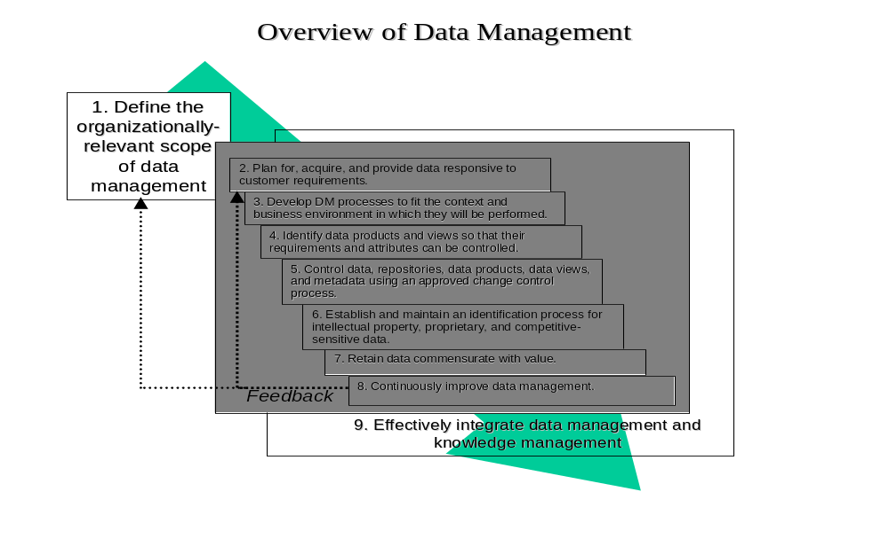Principles are high-level descriptive statements about high quality data management; they establish what high quality data management looks like. For each principle there is a set of enablers; the enablers provide the mechanisms of data management.
Figure Intro-1 Data Management Principles
Two different viewpoints are important to data management, corresponding to product and data life cycles. Product data (and related business data) is normally acquired or created in as part of the development of a new product or similar initiative. This is the realm of project management. Principle 1, which addresses the planning for and acquisition of data, and Principle 4, which deals with the identification of products, views, and related data elements, are written primarily from the perspective of the individual project. The remaining principles, which address development and implementation of consistent processes, are organizational- rather than project-specific. Principles 2, 3, 5, 6, 7, and 8 are written primarily from the perspective of the enterprise. Finally, principle 9 addresses continuous improvement of data management and applies to both the product and data life cycle perspectives.
The degree to which the DM principles in this standard apply to a product varies over the product’s life cycle. Similarly they vary in applicability over the data life cycle. Some principles may not apply during every phase of either life cycle.
This standard addresses the functions of data management but not how to organize for data management. Each enterprise will, for valid reasons, locate the functions of data management within organizational elements that make sense within its own enterprise environment.
This standard is not intended for use as a compliance document, or an evaluation mechanism, for DM projects. However, it is intended for use as a source and reference document for either purpose. Appropriate application of the functions and principles in this standard will enable the user to plan and implement a DM program for a product or for a project or enterprise.

Terminology
During creation of this standard, significant effort went into using wherever possible neutral terms. Known aliases, most of which are peculiar to the Department of Defense environment, for the neutral terms used in this standard are also provided in the glossary. There is no intent to express preference for any particular terminology set. When planning and documenting a DM program, these terms and other aliases may be substituted for the neutral terminology. Three particular sets of terms, however, deserve special mention. The first of these is the pair of terms program and project. In practice, the term “program” is often used to represent an undertaking that is larger in scope than a “project.” However such is not universally the case. This standard will consistently use the term “project.”
Second, this standard introduces some new neutral terminology used here in the context of data management for the first time. Where the terms are introduced for the first time they will be explained in context. The most important of these are probably the term data view, data view generator, data view description, and bill of data.
Historically, prior to the widespread availability of electronic databases, a data product was the result of extensive (and generally costly) manual work efforts to search out data from disparate sources and assemble it in the customer’s format. Given the effort and cost involved, it made sense to describe the result as a data product. Now, however, the manual effort is likely to be replaced by electronic extraction from an existing database; and the cost of retrieving and packing the data is much smaller. Further, what gets captured is a snapshot of data as seen from a particular perspective. Products become views of the data in the repository. A data view refers to the visual presentation of data by technologies such as digital images, geographical information systems, graphical user interfaces, multidimensional tables and graphs, virtual reality, three-dimensional presentations, and animation.
The data view description provides the agreed-to format, content, preparation assumptions, and intended use information for a data view. The data product format can be specified in a data item description (DID), in an eXtensible markup language (XML) schema, or by other means.
The list of data views to be provided in accordance with a contract is a bill of data, an example of which is a contract data requirements list (CDRL). A bill of data is a two-way concept: a supplier may need data from the buyer in order to perform under a contract. Further, in an integrated trading partner environment both trading partners may obtain views of data, as provided for in a bill of data, from a single data repository.
Finally, references to terms such as the enterprise, organization, or performing activity, developing activity, or producing activity refer to that organization or agency that has the responsibility for performing DM. This organization could be a commercial enterprise, a contractor, a subcontractor, or a government agency. References to the customer should be interpreted as the organization(s) that specify requirements. A customer may be external to the developing and producing organization; may be an internal customer such as marketing, management, or the using department; or may even be a supplier in a conventional sense. When the term “customer” is used without a qualifier, any of the three conditions applies. When a specific condition applies, the context will also be made specific.

References
This standard does not contain any provisions that, through reference in the text, constitute provisions of this standard. Therefore, there are no references.

Principle 1.
Define the Organizationally Relevant Scope of Data Management
Different organizations will come to different conclusions regarding the scope of data management. Historically, data management has been thought of as including five functions (Table 1-2).
Table 1-2 Common Functions of Data Management
Identification/Definition:
- Develop and maintain standard data requirement descriptions
- Review lifecycle of project or program to determine needs
- Identify overall data requirements
- Ensure completeness and eliminate duplication
- Provide support to program and enterprise management
Preparation:
- Of internal data, as identified and prescribed above
- Ensure that externally developed data meets requirements for internal use
Control:
- Establish and document control processes
- Implement controls for import and export of data
- Implement controls for proprietary information or property
- Implement controls for configuration management
- Implement prescribed forms/formats for authorization and use requests
- Prepare and maintain master inventory lists.
- Marking data (e.g., for retention level, proprietary data rights, classification)
Disposition:
- Establish and document records, custodians and project unique records management requirements
- Establish a plan for use of a document repository, whether physical or online
- Publish and make documents available
Archiving
- Create physical or digital files with appropriate archived information
- Create project files for decision-tracking histories
- Submit archival packages to higher and more general archiving facilities (internal or external) that specialize in data retention
These functions are still valid data management tasks. It is also the case that they are no longer a sufficient response to contemporary data management needs. What they do not provide for is strategic data management, to include design and maintenance of required infrastructure. Accordingly, the present standard defines a set of four higher-level data management tasks. They are
- Data management strategy and architecture development
- Data management process and infrastructure design
- Data management execution
- Data management process and infrastructure maintenance.
The tasks in Table 1-2 are almost all data management execution tasks. This standard adds tasks related to development of a data management strategy and architecture, related process and infrastructure design, and related process and infrastructure maintenance. The new tasks, require skills that have not previously been demanded of data managers (Tables 1-2 through 1-5). It should be abundantly clear that most of the skills are not resident in existing data management organizations, and probably will not be because of the diversity of organizations. A particular organization will not necessarily agree that all five functions will be part of data management as defined for that organization. Obviously, integration from a data management standpoint is improved by consolidating these functions and skills under one organizational entity. However, the cost might the sub-optimization of another process. Further, any particular organization may decide to simply forego one or more of these tasks--or at least to leave them unmanaged. This is clearly a choice that can be made. Like all choices it will bring advantageous and disadvantageous consequences.
Principles 2 through 9 in this standard were generally written from the perspective that data management includes all five of the major tasks and each of the enumerated sub-tasks. Tables 1-2 through 1-5 provide an overview of data management tasks and subtasks as defined in the present standard, as well as related skills. Appendix E provides a more complete cross mapping between tasks and skills.
Table 1-3 Strategy and Architecture
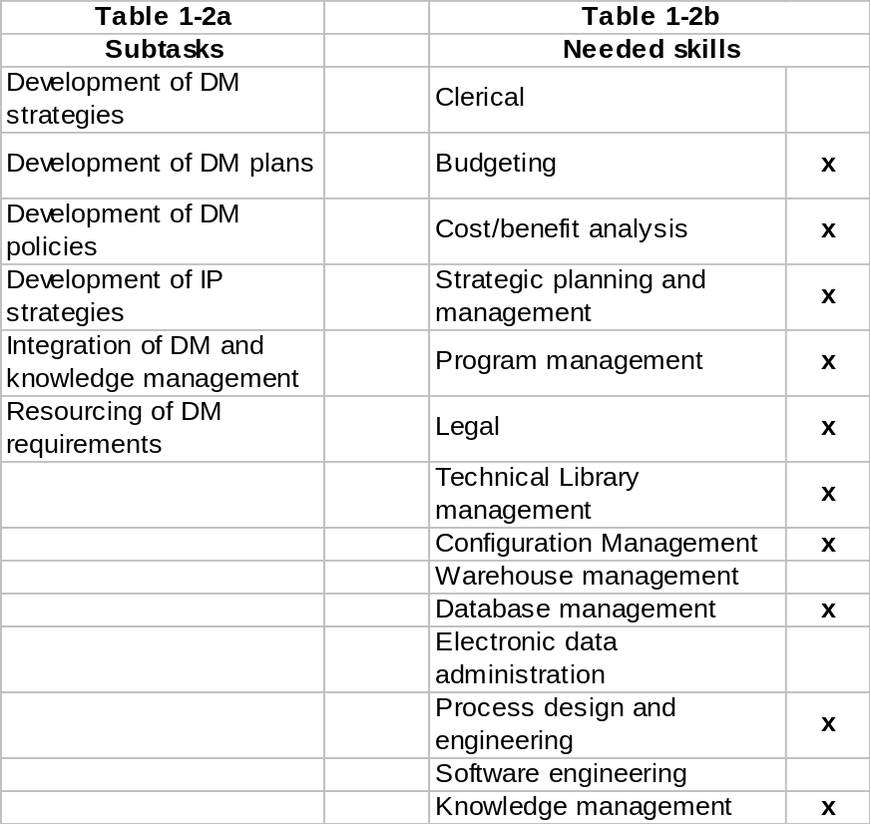
The right hand columns in tables 1-2 through 1-5 contain skills required by the major data management tasks. An “X” opposite a skill indicates that it is normally essential for one or more of the subtasks in the related table. Absence of and “X” indicates a skill is not normally essential to any of the associated subtasks, although it might be appropriate in some circumstances.
Table 1-4 Process and Infrastructure Design
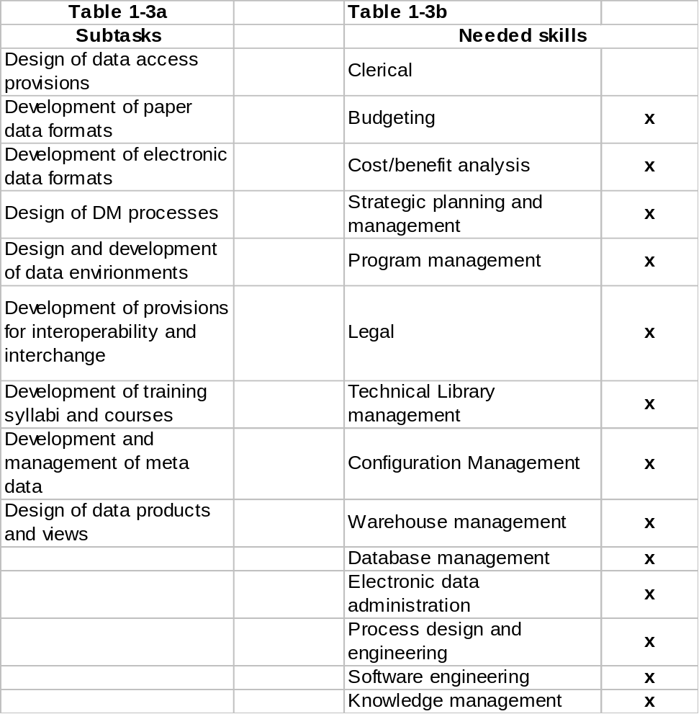

Table 1-5 Data Management Execution
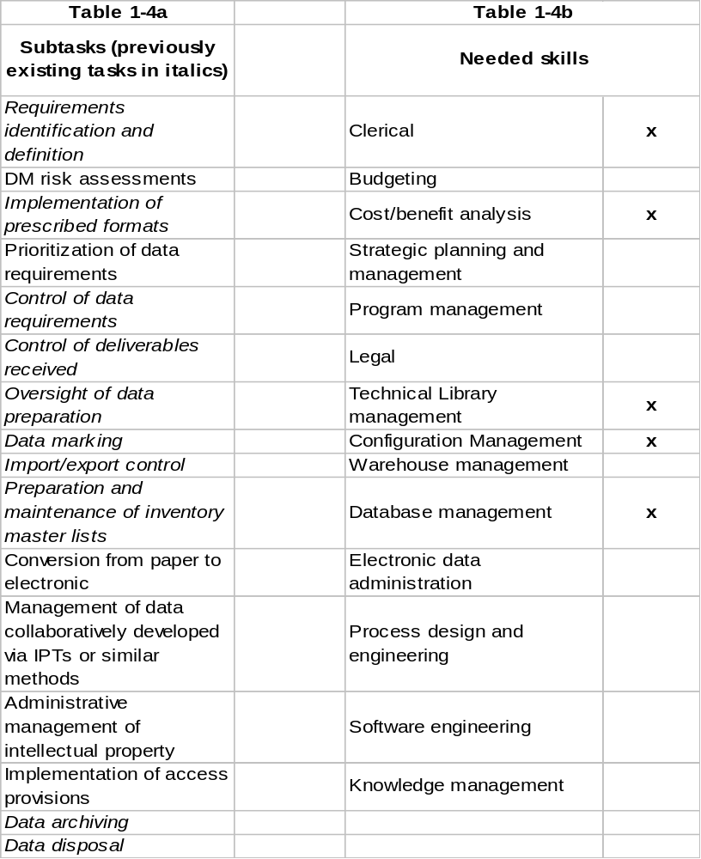
Table 1-6 Process and Infrastructure Maintenance
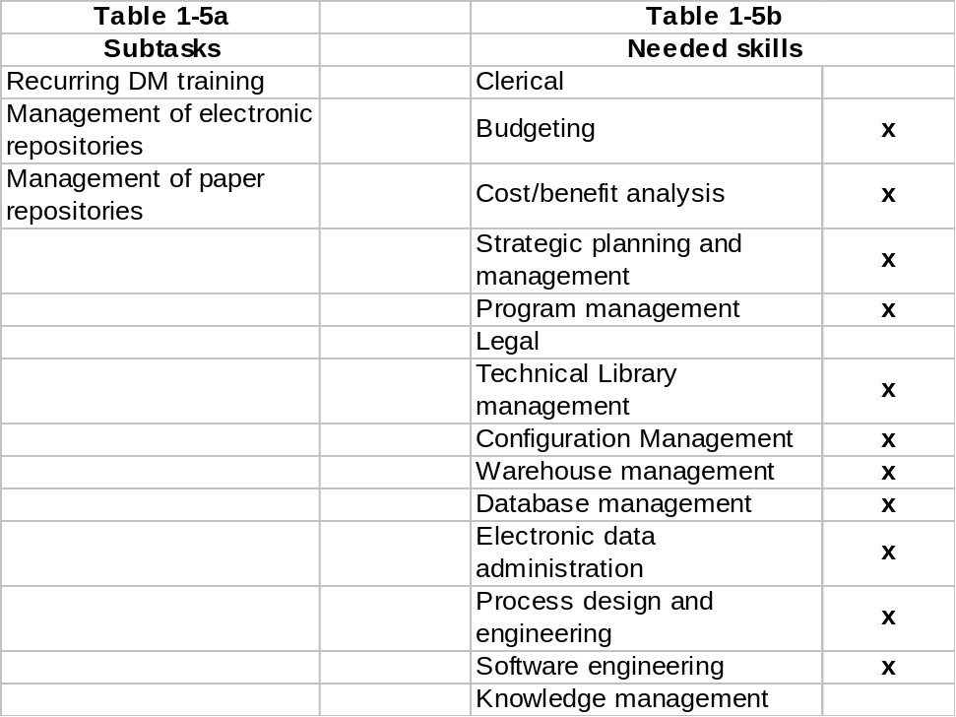

Principle 2
Plan for, Acquire, and Provide Data Responsive to Customer Requirements.
Introduction
In order to provide data that is responsive to customer requirements, plan for, acquire, and deliver or arrange for access to data consistent with the contemporary data management model (Figure 2-1). This principle addresses the steps in the model beginning with product need and ending with contract award. Later principles discuss data development; storage, retention and disposal; delivery and access; as well as important related topics.
Figure 2-1. Data Management Model
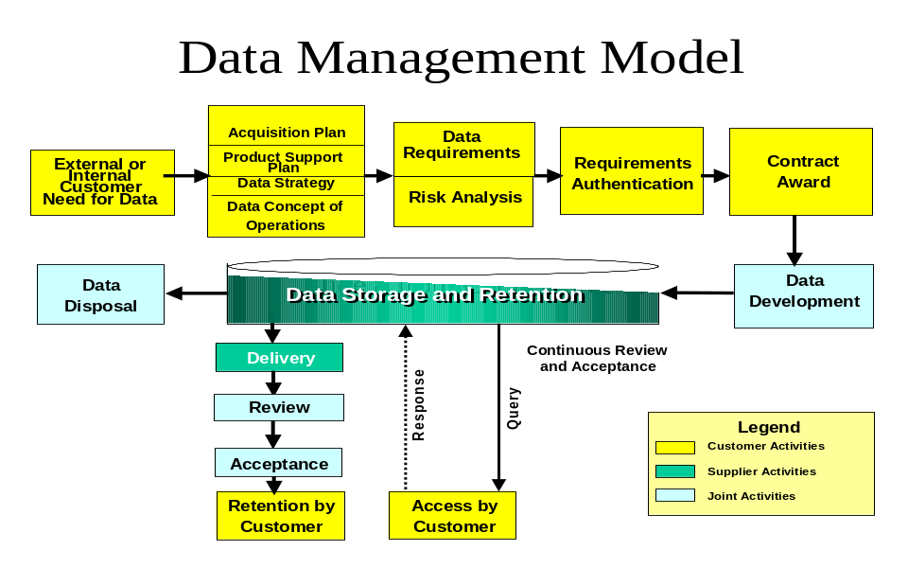
There are five aspects of this model important to the planning for and acquisition of data.
- First, the data customer can be either external or internal to the organization.
- Second, there two different methods by which data are provided to the customer. The mode of delivery can be
  - In hard copy or, increasingly, electronic form. In this case there is normally some process by which the customer reviews and accepts the data in the form of a data product, such as a report. The customer then retains and is responsible for the data.
  - By providing the customer access to the data in a database or repository maintained by the data developer or a third party. In this instance, there is usually some provision for continuous review and acceptance since data products in a conventional sense may not exist and data objects may be formed on the fly in response to customer-created queries against a database.
- Third, data development, review, acceptance, and disposal may be joint activities, conducted jointly by the data developer and customer.
- Fourth, planning for data is deliberately linked to the overall product acquisition strategy and long-term sustainment planning through development of a data strategy and data concept of operations.
- Fifth, the functional requirements authentication process, which has almost always existed in some form, is preceded by a data risk analysis that examines
  - The risks of not providing for delivery or access to data as well as
  - The risks of over-procuring data, particularly where the data may become rapidly obsolete.
The enablers for Principle 2, which follow the logic of Figure 2-1, are diagrammed in Figure 2-2 and detailed below.
Figure 2-2. Principle 2 Enablers
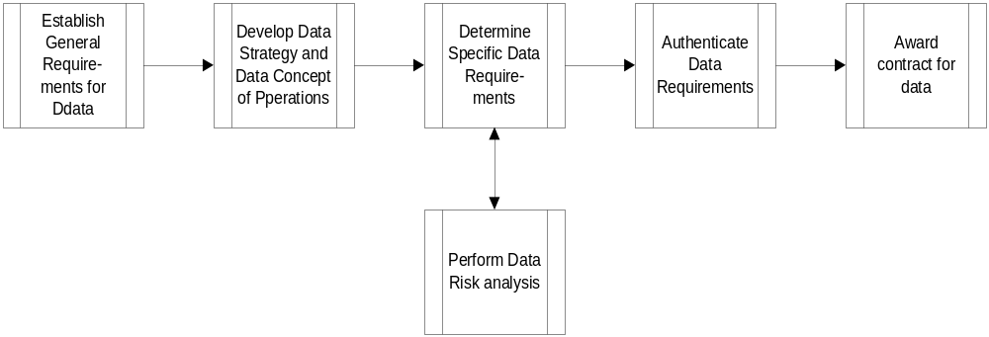

Enabler 2.1. Establish General Requirements for Data
The first step is to review the project strategy and planning to determine the anticipated general needs for data delivery and access throughout the product life cycle. This step is performed at the very beginning of the project before the project itself is fully defined. Because specific data requirements will not yet be known, a practical way to proceed is to examine the data requirements of recent, similar projects. The output of this enabler is a general description of potential requirements. At this point, before establishing a data strategy, it is not necessary or even desirable to attempt to define specific data requirements. This review should consider data that may be needed to support design oversight, business oversight, manufacturing, testing, operation and maintenance; and documentation that will be needed for legal, tax, historical, internal audit, or other valid purposes. The intent is to recognize the spectrum of data views that may be needed to support the project tasks and products throughout the product life cycle. (A data view is a generalization of the concept of a data product. The concept of the data view includes conventional data products whether paper or electronic, the results of data base queries, and electronic data interchange transactions.)
Included are not only project specific requirements, but also related data that may be needed to meet broader organizational or external requirements. It should be feasible at this point to anticipate if data delivery will be electronic, on paper, on paper equivalents such as microfiche, or by electronic access to a database.

Enabler 2.2. Develop Data Strategy and Data
Concept of Operations
This enabler is the project-level equivalent of Principle 3, “Match DM Processes To The Business Environment, Context, and Policies Of The Organization.” Principle 3 provides a more comprehensive treatment at the enterprise level.
Acquisition projects, whether commercial or military, exchange or provide for access to large amounts of product, business, and operational data. These data are central to both the acquisition process itself and to long-term sustainment after systems are fielded. Prior to the recent ability to move acquisition data cheaply via electronic means, commercial firms, their vendors, and government agencies primarily exchanged acquisition-related data via paper. In recent years, however information technology has had a significant impact on data acquisition and delivery--with requirements for paper data products rapidly diminishing. Simultaneously, information and other technologies are also reforming the business rules and technical infrastructures that govern how business operates. As a result, there is an ongoing need to analyze and match DM processes to the business environment, context, and the policies of the organizations in which they will be performed
A data strategy is important because all decisions, including those related to data, have consequences. A deliberate data strategy creates the potential for data-related decisions to contribute to long as well as short-term goals for the project and organization by aligning data management with the context in which it lives. The general data requirements (Enabler 1) define the data “mission” --what needs to be done for whom, how, and why--the first step in any strategic analysis. The next step in the formulation of a data strategy is a data environmental assessment (DEA) (Figure 2-3). The DEA, in the context of the general requirements, examines:
- The internal strengths and weaknesses of the project and organization
- External opportunities and threats
- Stakeholders, and
- Power sources
Figure 2-3. Data Environmental Assessment
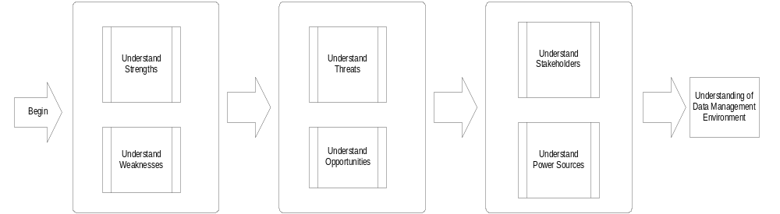A strength, for instance, might be the existence of defined processes and accompanying technical infrastructure for vaulting electronic data. A weakness might be lack of training on those processes. Strengths promote and weaknesses limit the ability of the project to satisfy the project data requirements. Understanding opportunities and threats external to the project reveals how the external environment can affect data management. An example threat could be a corporate intent to retire a database the project had intended to use. A classic opportunity is an informed customer who creates a need to develop new capabilities that have market potential beyond that customer. Understanding stakeholders and power sources is important because stakeholders will have to be satisfied and power sources influence resource allocation. Taken together, strengths, weaknesses, opportunities, threats, stakeholders, and power sources identified through the DEA define what can be done without change and what will need to change to satisfy the project data requirements. The DEA outcome is the basis for defining a course of action to solve gaps and capitalize on opportunities.
All the above basically determines if the needed capabilities will be in place and starts the process of creating them if they are not. It is also essential to describe how those capabilities will be employed. This is the role of the data concept of operations. The data concept of operations should cover:
- Who the customer is
- The range and depth of data to be provided, and over what period of time
- The nature of the business relationship, including how it is expected to change over time, if applicable
- How data views will be generated and provided to the customer (e.g., hard copy, electronic copy, in-situ access from a data server)
- Quality assurance provisions and
- Where resources will come from

Enabler 2.3. Determine Specific Data Requirements
The next step is to determine specific data requirements. The steps involved include determining who needs data, what data are needed, what views of the data are required (hard copy formats, responses to database queries, data interchange conventions, or other specifications), when the data will be required (in terms of project milestones or calendar dates), and the delivery mechanisms

Enabler 2-3.1 Identify and Define the Data Requirements by Reviewing the Project Life Cycle to Determine the Needs for Data
The first step in the process is to identify the data products that will be needed to support the project throughout its entire life cycle. Figure 2-4 shows the steps included in this identification process.
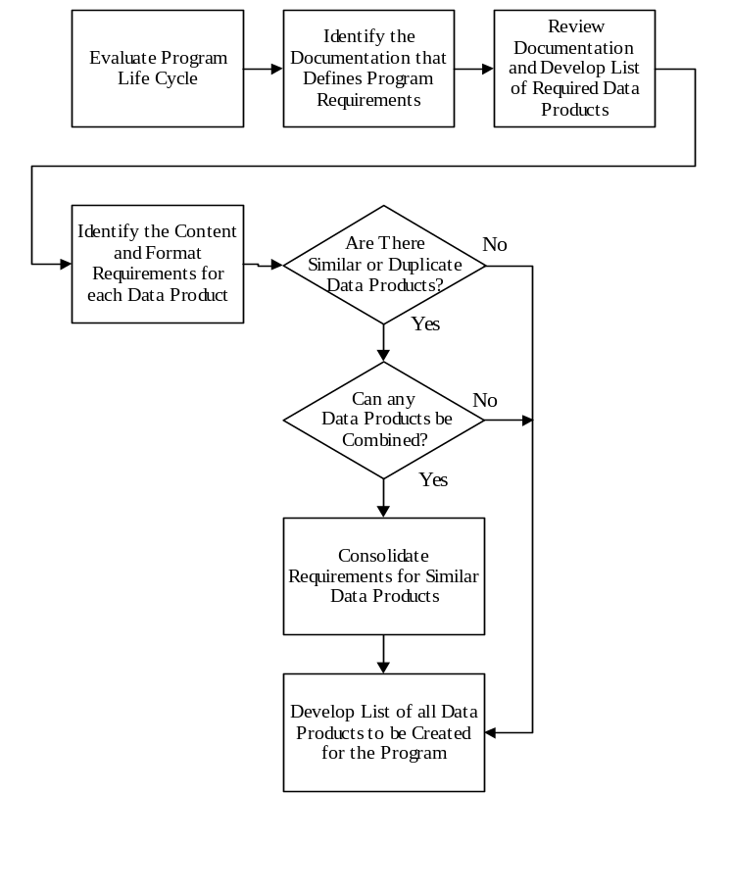
Figure 2-4 Review Project Life Cycle to Identify Data Requirements and Determine the Needs for Data
The first step in this process is to understand the project life cycle, and, in that context, to review the project requirements documentation to determine the types of data products that will need to be created. This review should consider documentation that will be needed to support manufacturing, testing, operation and maintenance; and documentation that will be needed for legal, tax, historical, internal audit, contractual, or other purposes. The intent is to recognize the data products that will be needed to support the project tasks and products throughout their entire life cycles. This includes not only project specific requirements, but also any data that may be needed to meet organizational or government requirements. Not all data requirements may be documented at the start of a project. There may be a need to anticipate some data requirements based on the potential for future need. As discussed under enabler 2.1, it may be useful to examine the requirements of analogous projects.
It should be recognized that the need for data products may change throughout the life of the project. Management should, assess the impact that any change to the project requirements has on the need for data products, or the requirements for those data products.
Once the types of data products have been determined, their specific content and format requirements need to be defined. This task includes the definition of the processes used to create each different type of data product.
As a part of the process of defining requirements, consideration should be given to consolidating the requirements for similar data products. Where possible and appropriate, the requirements for similar types of data products should be consolidated to minimize the number of items to be created, managed, and maintained.
The end result should be a consolidated list of data products needed to support the tasks and products of the project throughout their entire life cycle, the format and content requirements for those data products, and process information necessary to ensure that the data products that are created will meet the noted requirements.

Enabler 2.3.2 Identify the Users of the Data and Establish the Frequency of Data Delivery
The next step in the process is to identify the specific users of the data products and establish when the users need each of these items. A user may be either external to the enterprise--a customer in the usual sense--or an internal customer.
Need may be defined as a specific calendar date, or in relation to an event in the project life cycle. Figure 2-5 shows the steps included in this process.
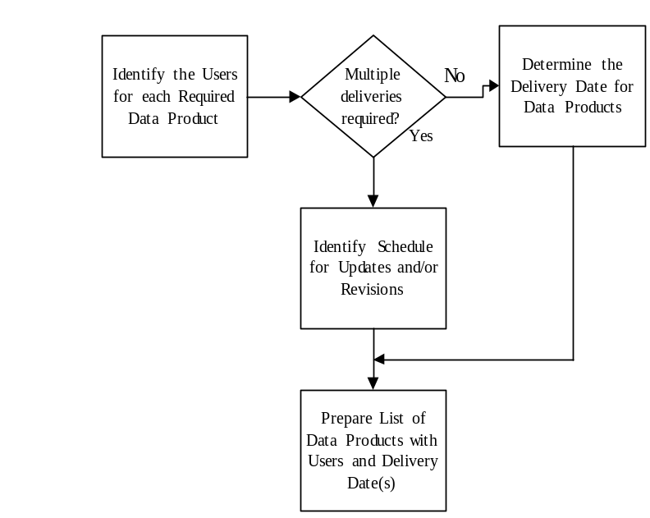
Figure 2-5 Identify Users of the Data Products and Establish When Data Will Be Needed
The process begins with (and requires as an input) a complete listing of the data products that have been identified as being necessary for the project.
Based on life cycle requirements of the project, determine the users who need to have access to each of the completed data products, and any interim data products. If multiple areas use a data product, note all area(s) that require access to the information.
Work with the users of each data product to verify the data products that they need, and the required need dates. If the data will be updated, or is periodic in nature, determine the necessary frequency for any updates.

Enabler 2.3.3 Relate Data Requirements to the Functional Areas Responsible for Data Generation and Distribution
Once the necessary data products have been defined and the data users identified, relate the data products to the functional areas responsible for creating the data. Note that more than one functional area may be involved in the creation of some data products. Figure 2-6 shows the steps included in this process.
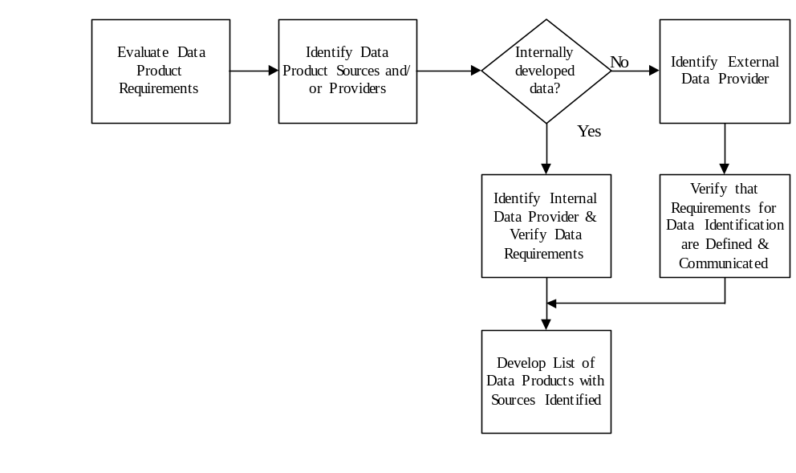
Figure 2-6 Relate Data Requirements to the Functional Areas Responsible for Generating the Data
The process requires as an input a complete listing of the data products required by the project.
Based on the type of data, determine the functional area (or areas) that are responsible for the generation of each of the data products. If a data product requires input from multiple areas, note the areas that provide source information and the area with final responsibility for the finished data product. Ensure that the data requirements, including marking requirements, are clearly defined and documented. If an internal source is responsible for the preparation of a data product, organizational procedures should ensure that data requirements are communicated to the responsible functional area(s). If a subcontractor or other outside source is responsible for the preparation of a data product, ensure that the requirements are properly communicated. Relate each data product to the functional area that has responsibility for the finished data product and note any dependencies that exist for source data from other functional areas.

Enabler 2.4. Perform Risk Analysis
Data management incurs multiple sources of risk. They include:
- Failure to provide data that is needed when it is needed
- Over-provisioning data, providing data that is not used or providing data before it is needed.
- Inability to find data as a result of non-existent or inadequate cataloguing and meta-data
- Data loss
- Data obsolescence, and
- Data theft
Although the specifics of each project will differ, a demonstrated risk analysis method is to:
- Enumerate the sources of risk
- For each risk determine
  - The probability of occurrence and
  - Severity of consequence if the risk materializes.
Simple scales (e.g., high, medium, low, low) often are good enough to characterize both probability and consequence (Figure 2-7). Priority for risk mitigation then belongs to those risks that, in relation to others, have combinations of higher probability and consequence.
Figure 2-7 Example Risk Portrayal
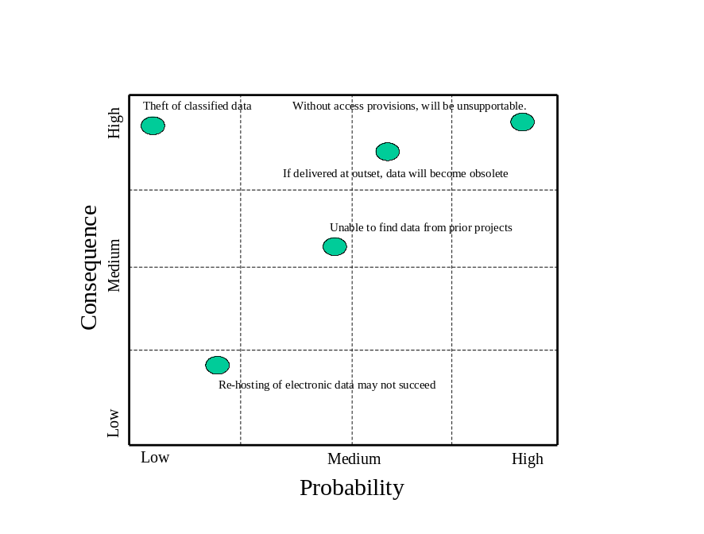
Characterization of the first two sources of risk (under and over provisioning) is an important input to data authentication. It provides a basis for understanding and defending data requirements that should be satisfied, as well as those that should not. Understanding the third through sixth is important to process adequacy and potential process redesign. There may, be other sources of risk as well; this list is not intended to be comprehensive.

Enabler 2.5. Authenticate Data Requirements
Authentication is the capstone task prior to either contracting for authorizing internal development of data. The purpose is to make sure that requirements as defined in a bill of information are valid, complete, and make sense from a business standpoint. In authenticating data requirements, address the following questions as a minimum.
- Are a DM strategy and DM plan in place to guide overall data acquisition for the affected project? Are the strategy and plan adequate? Does the proposed procurement of data follow the strategy and plan?
- Does the proposed bill of information respond to user requirements? Specifically does the content as well as the types, formats, and delivery or access timelines respond to user and enterprise needs?
- Has a risk assessment been performed. Is the risk assessment reasonable?--i.e., are the risks understood and the approach to risk mitigation reasonable?
- Have requirements been adequately integrated to resolve duplicate requirements? Did the integration effort look for and resolve implied or missing requirements? Were non- or low-value added requirements sought for and resolved?
- Are adequate quality assurance measures specified so that the data received, generated, and used will be appropriate and suitable?
- Have data rights issues been addressed adequately?
- If future access or contingent requirements are involved have data maintenance, configuration management, and (if appropriate) escrow provisions been addressed?

Enabler 2.6. Award Contract for Data
Contract award is the final enabler for this principle. Here the term contract is intended to include formal contracts between two companies, formal contracts between a government agency and a company, interdepartmental work authorizations within a company, memoranda of agreement, and any other form of agreement. Data may also be provided through a stand-alone contract or, and more generally, as part of a larger contract for goods or services.

Principle 3
Develop DM Processes to Fit the Context and Business Environment in Which They Will be Performed.
Introduction
To be effective, data management solutions, processes, and practices should be developed within a realistic analysis and understanding of the business context and environment in which they will be performed. The business context and environment are characterized by both internal and external factors; data management solutions are necessarily conditioned by those factors. Requirements to be satisfied come not only from projects themselves but also from future expectations related to projects, from enterprise policies and processes, and from the environment external to the enterprise. Taken together these sources define the context and business environment in which data management will operate. illustrates the comprehensive DM requirements space (Figure 3-8).
Figure 3-8 DM Requirements Space
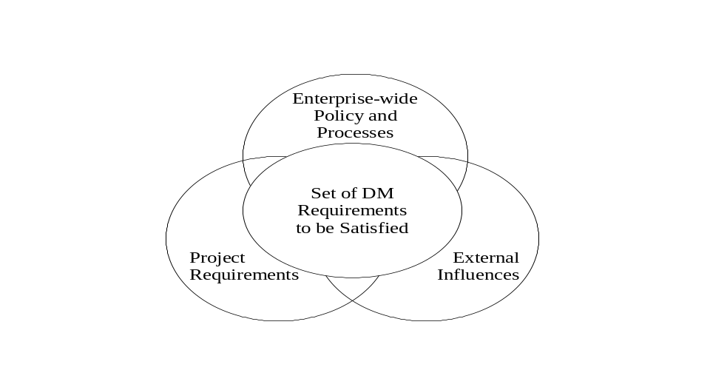
In a particular circumstance the project-specific, enterprise-wide, and externally imposed requirements can be synergistic or additive. In this instance, planning for their solution amounts to identifying all of the requirements and deciding, within finite resources, which can be satisfied, when, and how. But the requirements can also be in conflict. An example would be a requirement for enhanced data sharing and a simultaneous requirement to improve controls over intellectual property. Regardless of whether they are synergistic, additive, in conflict, or--more likely--a mixture of the three, it is data management’s task to identify and then address the full set of requirements, including examining trade-offs where appropriate.
The identification of project-specific requirements is addressed by Principle 2. Enterprise requirements and the requirements arising from the environment external to the enterprise are integrated with project-specific requirements by the current principle. This principle addresses the four (4) major components of a successful data management solution
- Deriving the complete set of data management solution requirements
- Determining the shape of the preferred DM solution
- Comparing the proposed, best solution to existing and planned enterprise process infrastructure and
- Developing needed adjustments that fulfill the total set of DM solution requirements by resolve gaps and conflicts.
Enabler 3.1. Determine the complete set of requirements that the data management solution must address.
Prior to developing new DM strategies and solutions, identify the general set of requirements to be addressed. This includes not only the requirements for data, but also the broader requirements that relate to data capabilities and data processes. In order to get at these broader requirements it is important to understand, as a minimum, the intended use of the data, related business objectives, technology issues, and external constraints. The steps listed in Figure 3-2 outline a process for developing a complete set of requirements.
Figure 3-2. Process for Understanding Requirements

Determine the expected life cycle of the data.
Determine requirements for access and delivery.
Determine who will create, access, update, and dispose of the data.
Determine related business objectives.
Determine related organizational policies
Identify external forces

As illustrated in Figure 3-2, among the essential considerations are the following, although this list is not exhaustive.
- Determine the expected life cycle of the data and expected use of the data over the life cycle. Are data being developed or acquired against a one-time requirement or is there likely to be a future requirement for the data.?
- Determine who will create or acquire the data. At least three situations can apply: client developed or acquired, developed or acquired for the client, or collaboratively developed (Table 3-7)
Table 3-7 Creation and Acquisition of Data
Who creates or acquires | Passes through “hands” of data manager | Considerations
Client developed and provided | Yes | - Important to understand what the client expects in the way of data inventory management and protection for data provided
Developed or acquired for the client | Yes | - Realm of “traditional” data management and, assuming reasonably unambiguous requirements, the easiest for which to plan.
Collaboratively developed | Probably no. | - Growing in prominence as a result of increased use of integrated product/process teams (IPTs) and other trust-based relationships.  - Data management task is to put in place the means and processes for IPT-level self-management and then to oversee that self-management.
- Assuming other than a one-time requirement, determine the expected requirements for access, for delivery, for maintenance, for storage, for protection, and for disposal over the life cycle. As an example, it is reasonable to expect that data created during the early design phases of a project will be important during later phases. As another example, it is important to determine if the client is likely to want delivery or access.
- Determine who, over the life cycle, will have access to, be responsible for updating, and be responsible for disposing of data (Table 3-8). Assess which of these cases is the most likely, and plan accordingly.
Table 3-8 Responsibility for Updating and Disposing of Data
Case | Comments
Client has requested delivery with no provision for updates | Client may take responsibility for maintaining the data current, or it is possible that the client has not yet considered the need for update and disposal.
Client has or is likely to request access rather than delivery | Client will probably want the data developer to maintain the data current and may require escrow provisions as a form of insurance that data will be available
- Determine if there are related business objectives and considerations. For instance,
  - Will the data potentially be reused or repurposed?
  - Is there any provision for warranting the correctness of the data? If so then clearly this need to be taken into account and planned for from both a process and financial standpoint.
  - Is some or all of the data important from an intellectual property standpoint?
  - If there is, or is likely to be, a requirement to provide for continued long-term access, what are, or are likely to be, the provisions if the organization, through reorganization, a buyout, or other means, ceases to exist in its current form.
  - Does the organization want to be in the business of data warehousing (for either electronic or non-electronic data) or will this responsibility be outsourced to a third party?
  - Is the data requirement indicative of an emerging market for the organization, a market the organization is maintaining, or a market the organization intends to withdraw from? The appropriate investments (time, infrastructure, acquisition of staff, training) are different for each case.
- Determine what organizational policies pertain? For instance,
  - Does the organization have in place policies that promote either centralized or decentralized management of data?
  - Does the organization have in place policies related to retention and disposal?
  - Is there a formal or informal policy related to disaster planning and recovery, such as maintaining data in more than one physical location?
- Identify what external forces apply.
  - Has the client requested compliance with national or international standards? If so, then it will be important to understand the extent to which changes in the standards, some of which cannot necessarily be foreseen, will create new requirements?
  - Similarly, has the organization adopted national or international standards that apply?
  - Are there either national or international legal requirements (e.g., with respect to intellectual property such as patents or copyrights) that have to be respected?

Enabler 3.1. Determine the Shape of the DM Solution.
The next step is to consider the broad characteristics of the DM solution and what it must address, but not yet “how” the solution will be implemented. A complete solution includes an analysis of all factors: internal, project-specific, and external. Figure 3-3 illustrates the essential steps, a matter of applying standard systems engineering precepts to the development of a data management solution. Although the process in Figure 3-3 and described below is portrayed as linear, it generally is iterative, especially requiring some cycling back and forth between alternative development and prioritization.
Figure 3-3. Process for Determining the Shape of the DM Solution
Prepare integrated requirements.
Determine synergies and conflicts
Develop alternative solutions

Perform prioritization and trade-offs

Select best solution

The first step is to assemble the requirements identified by Enabler 3-1 in a form that can be worked with for purposes of data management solution design. One way to do this is to list the requirements according to their source and relative priority. As an example, group requirements in terms of:
- Current external client contract requirements for specific deliverables or access requirements
- Current internal client contract requirements for specific deliverables or access requirements.
- Vendor requirements--i.e., requirements for data that come from sub-contractors and vendors rather than external or internal clients. An example might be a set of envelope drawings that a vendor needs in order to proceed with detailed design.
- Derivative, intermediate datasets required to satisfy external or internal client requirements. As an example, even though a formal logistics support analysis may not be called for in the contract from an external client, the logistics support analysis may still be needed in order to determine sustainment requirements and design a supply chain.
- Anticipated near-term new contract or internal requirements for deliverables or access requirements
- Anticipated longer-term contract or internal requirements
- Requirements imposed by organizational policy and practice.
- Requirements, such as those found in the uniform commercial code or law, which come from the environment outside the organization.
Normally the requirements from the process just described will not be fully independent of each other (Table 3-9)
Table 3-9 Interdependent Requirements
Case | Comments
Duplicative requirements | Important to detect and look for ways to combine requirements so they can be satisfied with a single rather than multiple efforts
Conflicting requirements | Can be simple--such as needs for the same or similar data, but at different points in time.  Can be more complex -- such as competing needs for data sharing and protection of intellectual property rights.
Synergistic requirements | - Example is case where the data created in response to one requirement when integrated with or augmented by data created in response to a second requirement provides a solution to a third requirement.  - Almost always introduces time dependencies; important to capture interdependencies in a process chart, network chart, or by similar suitable means.
The method for portraying integrated requirements will vary from circumstance to circumstance. In some cases, a simple database is sufficient. In others, particularly where process and capability considerations are important, a narrative report may be required. A strong data management solution depends on a clear understanding of the relationships.
The second step is to develop a set of alternative solutions for the comprehensive set of requirements. Each solution is a scenario: a particular combination of processes, organizational elements, and infrastructure elements. The processes, organizational elements, and infrastructure elements do not need to already exist. In fact, it would be a mistake to consider only elements that exist since doing so will almost certainly constrain improvement. In particular, do not be limited by pre-existing policies and practices. These policies and practices are essentially the “residue” of previous decisions. Although valuable because they represent organizational learning they can also be deleterious if that learning is not relevant to the problem being studied. Whether or not the cost (monetary, labor, time, and or good will) to change policy or practice is worth it can be considered as part of the evaluation process.
Step two, generating alternative solution is typically the most difficult of the steps because it involves idea generation; it is harder to envision what could be than describe what is. Consider creating alternative solutions through some form of brainstorming exercise since it is proved to be effective. As an aid to creating alternatives, this is the point in the process to identify and consider incorporating best practices. When a set of candidate alternatives has been generated, perform a top-level, first-order analysis to separate feasible from infeasible alternatives. For instance, there is no point considering an alternative that violates rules of physics or would require resource investments beyond any that has any likelihood of being available.
The third step is to prioritize the feasible solutions in terms of their ability to satisfy the requirements and cost of implementation. This is almost always a matter of comparing multiple solutions in terms of their ability to satisfy multiple objectives. Perform this step by doing the following:
- Prioritize the requirements in terms of high medium low, on a nine-point scale, or through some similar notation.
- Evaluate the ability of each solution to satisfy each requirement, again using an appropriate scale.
- Evaluate the implementation cost of each solution on an appropriate scale (e.g., negligible, low, medium, high, very high). Highly precise cost estimates are not normally worth the effort to prepare them at this stage of analysis. Since more than financial costs are normally involved be certain to consider non-monetary as well as monetary costs using a similar scale.
- Determine which alternative does the best job of satisfying the most important requirements at the most attractive cost and risk. Although this process can be painstaking, the tradeoffs associated with alternative solutions are frequently those most important to the decision making process. Well-crafted solutions yield positive results for the enterprise, better processes and practices for the future, and even development of competitive edge methods.
The structured approach described above may show that no proposed alternative solution will satisfy enough of the priority requirements to be satisfactory. If this happens then it will be necessary to back up a step and craft additional alternatives. It is also possible that, even after considerable effort, there does not appear to be a feasible alternative. In this case it may be necessary to go back one more step to make sure the requirements were correctly understood and, potentially challenge them. Those who established requirements did not necessarily have available to them an understanding of the feasibility or affordability of solutions that would satisfy them.
The final, fourth, step is to select the best solution, given all relevant considerations. The third step will have identified the best overall solution, framed in the context of benefits, risks, gains, and losses that other solutions may represent. In this, final, step, that ranking is reviewed for reasonableness and, in addition, considerations that are relevant but may be difficult to quantify are also considered.

Enabler 3.2. Compare the proposed, best solution to existing and planned enterprise capability (infrastructure and processes).
Since virtually all organizations will have some data management capability already in place it is important to compare the needs of the proposed, best solution to existing and planned enterprise capability. To some extent enabler 3-2 will have already done so, especially when estimating costs. The current enabler formalizes the process and Figure 3-4 depicts the methodology.
Figure 3-4. Process for Comparing Proposed Solution to Existing and Planned Enterprise Capability
Enumerate process, practice, policy, organizational, and infrastructure assumptions of preferred solution
Perform gap analysis: compare assumptions to existing processes, practices, policies, organization, and infrastructure.

Estimate implementation costs of needed changes.

By detailed examination of the preferred solution, identify process, practice, policy, organizational, and infrastructure characteristics that are required to implement it.
Perform a gap analysis by comparing the needed characteristics to those of existing processes, practices, policies, organizational alignments, and infrastructure. For instance, if the preferred solution involves assured electronic storage of quantities of digital data over extended periods of time, it will be necessary to determine if the organization’s infrastructure plans are supportive. Similarly, if the preferred solution involves processes different from those in place then reengineering of the processes will be required. As part of this step, identify any conflicts or roadblocks (e.g., organizational plans to remove infrastructure that will be needed) that will have to be overcome or considered. It is unlikely that all current processes, practices, policies, and infrastructure capabilities are already documented in an easily retrievable form. So, part of the gap analysis effort may entail a knowledge capture and subsequent documentation effort sufficient to perform the gap analysis.
Finally, determine the monetary and non-monetary implementation costs of the needed changes. Since this estimate will provide a basis for advocating for and allocating resources, monazite the resources (e.g., in dollars) within an acceptable range of uncertainty (e.g., 10%)

Enabler 3.3. Make needed adjustments in processes, practices, policy, organizational alignment, and infrastructure.
Using the comparison results derived in the previous enabler, make needed adjustments to resolve the gaps (Figure 3-5).

Figure 3-5. Process for Making Needed Adjustments in Processes, Practices, Policies, Organization, and Infrastructure
Based on gap analysis, enumerate process, practice, policy, organizational, and infrastructure changes that are required.
Develop a time-phased, resourced, strategy to fill identified gaps.

Monitor Implementation and Perform Course Corrections as Needed
Implement the Strategy

The first step, which will have been largely completed in the prior enabler, is to enumerate the needed changes in processes, practices, policy, organizational alignment, and infrastructure.
The second step, using the comprehensive list of needed changes, is to develop a time-phased, resourced strategy to resolve the gaps. There are many reasons for devoting an appropriate amount of effort to the development of this time-phased strategy. They include the following considerations:
- Not all requirements will need to be satisfied up-front. Since money has a time value, investments should be delayed until they are lead-time away from need. There is a secondary benefit of lead-time away implementation: there will be less uncertainty what the requirements are.
- The organization may not be able to provide all of the resources up-front based on simple budgetary considerations. However, a carefully considered plan will enable the organization to address value-added and thus evaluate future resource needs from a better-informed perspective.
- Organizations can only absorb so much change at once in any event. Particularly where changes in processes, practices, and organizational alignment are involved, it will be important to develop buy in and avoid pushback--through appropriate education and other forms of outreach and communication. Time needs to be allocated for outreach and communication.
The third step is to implement the defined strategy.
The fourth step -- an essential step -- is to monitor implementation and make course corrections as needed. Aside from detecting implementation problems, it is unlikely that the solution was as completely correct as initially envisioned. Further, there will be fact-of-life changes in requirements as time goes on that will need to be provided for and addressed.

Principle 4
Identify Data Products and Views so That Their Requirements and Attributes can be Controlled
Introduction
Data is of value to the organization when it can be located or accessed by users. Metadata, or data about data, is essential for data managers and others to identify, catalog, store and retrieve data. Metadata includes attributes and relationships and is further described in enabler 4-1. Careful consideration of requirements when selecting elements of metadata enhances the ability of users to locate data regardless of storage medium or the size if the data store. Creating standard processes for selecting metadata provides for consistent, uniform, repeatable processes that can be tailored to specific business requirements. Further, using uniform processes saves time, reduces cost, and allows projects to reap scale effects through adoption by multiple users or organizations that exchange data.
Not all data is delivered as a data product per-se; if anything the trend is away from delivery and towards access as needed. When access is provided for, an authorized user can retrieve data that has been grouped or organized to meet specific needs--what is referred to in this standard as a data view. Data views, whether implemented as queries, XML schema, or by other means are described by meta data. Particularly where the data views are complex and when it is important to ensure that the exact same view is provided each time it is needed it is important to define and control the meta data.
The purpose of this principle is to ensure that metadata is selected to enable effective identification, storage, and retrieval of data so that the creation and retention of data can be properly managed. Figure 4-9 illustrates the process at the top level.
Figure 4-9. Data Product Identification Enables the Control of Requirements and Attributes
Establish relevant attributes to define data

Assign unique identifiers
Identify users and requirements
Develop consistent methods for describing data
The process begins with identification of users and a review of the requirements to identify data that will need to be developed or procured. This can be an iterative process that may reveal additional data requirements.
The second step is to develop consistent methods for describing data. Doing so avoids the confusion that comes from calling a data element an “author” in one context, “person_author” in another, “document_author” in a third and so on when they all are describing the same thing. The third step is to use the consistent methods from step two to establish relevant attributes for the project’s data. The next step is to assign unique identifiers, what are usually call “keys” in database terminology. The unique identifiers are the attributes (e.g., document number and version number) that make it possible to unambiguously distinguish one product from another. Each of these steps is described in more detail in the lower level enablers.

Enabler 4.1 Develop Consistent Methods for Describing Data
While the types of data to be managed vary among organizations and projects, the process for establishing metadata can be standardized. Consistent development and use of meta data enables effective communications across organizations exchanging data as well as within and between organizations over time. The process for selecting metadata should be coordinated with users or other organizations to ensure compatibility among those who will exchange data. Process templates can be used to provide a consistent, repeatable method for identifying the data products and flow of data among organizations
Attributes are the properties that uniquely characterize the data, such as document number, title, date and data types. A metadata record consists of a set of attributes necessary to describe the data in question. While identification of attributes initially occurs during the early stages of planning, it should be seen as an iterative process throughout the data life cycle. New methods of data storage and new types of data may evolve, requiring different ways of storing and retrieving data. Changes to metadata should support multiple paper or electronic storage and retrieval approaches, while maintaining the integrity of existing attributes. See Figure 4-10.
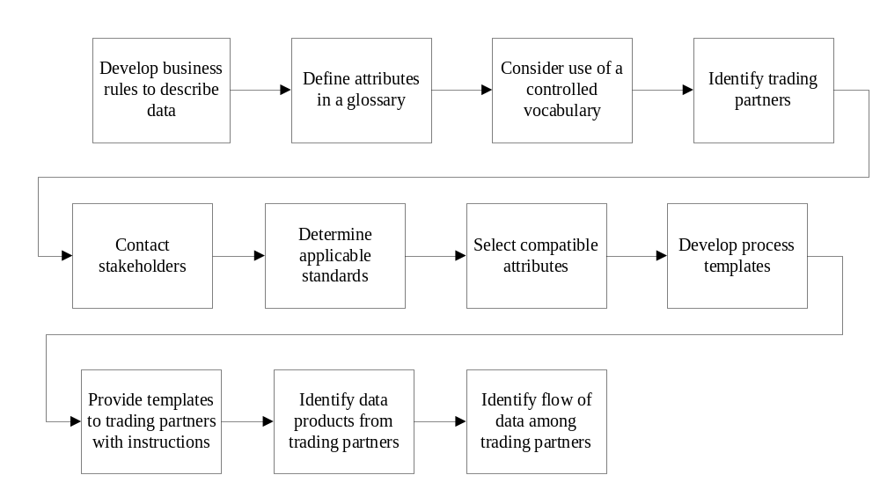Figure 4-10 Process for Consistently Describing Data
Develop business rules to consistently describe data throughout the life cycle. Select attributes from a "controlled vocabulary," which is a limited set of consistently used and carefully defined terms. This is critical to ensure effective retrieval. Without basic terminology control, inconsistent metadata will diminish the quality of search results. Ideally the controlled vocabulary is not project specific but is accomplished at the enterprise or higher level in the form of a standard data dictionary or similar means and applied consistently to all projects (see enabler 4.1.1 below).

Enabler 4.1.1. Ensure Data Interoperability Between Team Members
During selection of metadata attributes, identify team members who potentially exchange data, enter data into a repository, or search for data. Contact team members to obtain input and coordinate requirements. While it is desirable to standardize attributes it may be expensive to do so if modification to existing data systems is required. An alternative is for each to map to a neutral standard. In any event, any standards invoked by a customer should be flowed down to team members and understood by all parties. Use of standards, such as EIA-836, Configuration Management Data Exchange and Interoperability and the Universal Data Element Framework (UDEF) enhances the ability to exchange data.

Enabler 4.1.2. Apply Processes to Characterize Data and Data Products to Ensure Adequacy and Consistency
Process should be developed to map the flow of data throughout the life cycle. The use of a template provides a consistent, repeatable method to identify data products and the flow of data between users. Data owners and users are identified in the process, along with any requirements associated with metadata. Use of templates will help ensure consistency across the organization in defining data products.
Once processes are developed and tested, users should be trained in using the templates to identify the data products. Users should be provided with the templates along with instructions for use and possible tailoring. The purpose, expected results, and any ground rules should be identified to assist users in accomplishing their goals. Consistent use of the templates helps in the exchange of data among users. Table 4-10 is intended as a representative sample of some types of attributes that may be selected by an organization. Specific titles and descriptions are defined by the project, or organization to meet specific requirements. A glossary, often referred to as a data dictionary, will be required to define each attribute. An attribute such as “Document Type” can mean different things on different projects and to different organizations although the use of a controlled vocabulary will act to restrain unnecessary proliferation.
Table 4-10. Metadata Examples.
Attribute | Description
Author | Originator of the document or file
Classification | Level of security classification or business sensitivity
Contract Identifier | Contract number or other identifier
Date Modified | Date of revision
Date Originated | Date of document or file. May be date of creation, date of approval, or date entered into repository.
Document Number | Unique number assigned to a document using a numbering convention developed by the organization or project
Document Owner | Individual authorized to make or direct changes to the document
Document Size | Physical size of document such as 8-1/2 x 11, 3 x 5, roll microfilm, etc
Document Type | Defined by project to describe general content type, such as report, plan, agenda, test procedure
Environmental Requirements | Defines any environmental considerations for storage
File Format | Software application used to create the file, such as Word, PowerPoint, ProE, Adobe Acrobat, etc. Sometimes includes version, such as Word 6.0
File Size | Size of electronic file, usually identified electronically by the system when entered into a repository
File Type | Describes physical characteristics such as hard copy, microfilm, electronic, etc
Organization Identifier | Identifies organization, department, or project
Related Document ID | Identifies other documents to which the document is related
Related Product ID | Identifies products to which the document is related
Revision Identifier | Unique identifier for data revision or version
Rights | Rights and limitations in access and use of data
Storage Medium | Electronic, file cabinet, card catalog, etc.
Subject | Subject matter of the document or file
Submittal Date | Date of formal submittal to customer, trading partner, supplier, etc
Title | Document title or other descriptive information defining the content of the document or file

Enabler 4.2 Establish Relevant Attributes to Refer to and Define Data
Figure 4-11 shows the factors that should be considered when selecting attributes.
Figure 4-11. Develop a Process for Selecting Attributes
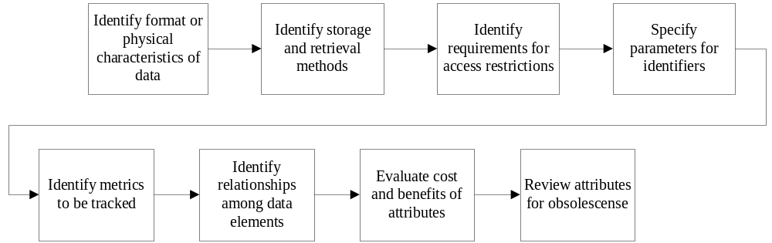
In order to catalog, store, and retrieve data understand the format of the data to be managed. Electronic files are managed differently than hardcopy paper or microfilm, so the physical characteristics should be taken into consideration when establishing attributes. File format, or the software application used to create or view the file, is relevant for retrieval of electronic files but not for data stored only in hardcopy format.
The storage medium and file formats influence the selection of attributes. Selection of attributes to support identification of storage medium is useful in planning for storage facilities. For example, identifying the file size of data to be stored electronically will help identify the resource allocation.
Access to data is restricted based on proprietary issues, security issues, or other limits in data rights. Attributes are selected to identify data that requires special handling or limited access. This protects the organization from inadvertent disclosure of data to inappropriate parties. For more information, see Principle 6.
Requirements for tracking and reporting metrics should also be considered when selecting attributes. Metrics are typically used to monitor throughput and ensure that the process is operating as intended, or to ensure that resources are properly allocated. Organizations that routinely track certain metrics should assist in creating standard attributes to enable the collection of metrics. For more information, see Principle 9.
It is important to weight the cost of creating and entering metadata attributes potential benefits. If users are required to complete numerous metadata entries when placing a document in a repository, it is likely that documents will be entered with missing or erroneous entries, or that documents will not be entered into the repository at all. Potential attributes should be evaluated based on whether there is value added in tracking and locating data. The set of required attributes should be kept as small and simple as possible to allow a user to create simple descriptive records and provide for effective retrieval. Any existing metadata standards should be tailored to meet needs.
Metadata attributes change over time due to evolving requirements throughout the life cycle. These changes include changes to the data repository (e.g., facility or system upgrades) as well as obsolescence. Part of the overall data management process includes periodic reviews of metadata attributes.
When modifying attributes consider the impact on legacy data. In a large repository, it may not be feasible to update metadata attributes of existing data. Since, when such is the case, searches based on new attributes may not be successful in locating legacy data it may be necessary to develop translation tables or similar mechanisms.

Enabler 4.3 Assign Unique Identifiers to Distinguish Similar or Related Data Products from Each Other
Identifiers are assigned to uniquely identify or name specific data. The complete identifier for data consists of a number or title, the source of the identifier, and the revision. Figure 4-12 shows the steps included in the assignment of identifiers. The requirements for document identification are discussed in EIA-649, National Consensus Standard for Configuration Management, and EIA-836, Configuration Management Data Exchange and Interoperability.
Figure 4-12. Unique Identifiers are Assigned to Distinguish Similar Data Products
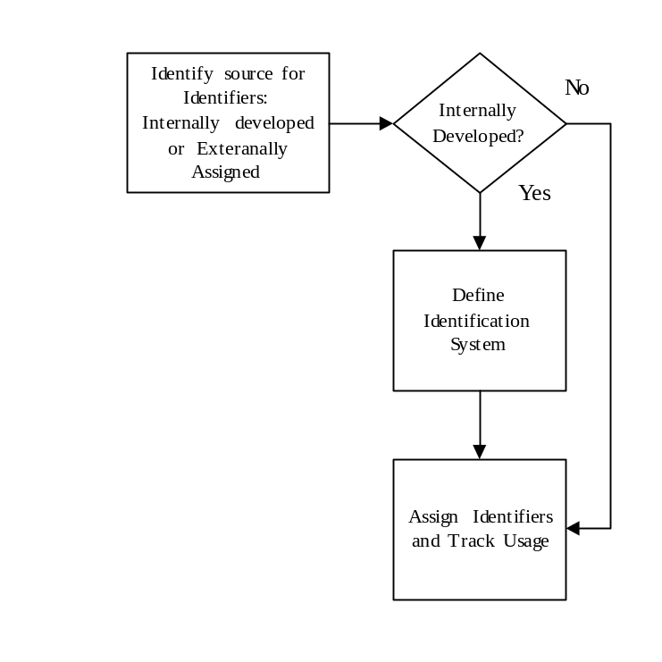
The first step is to ensure that a unique identifier is needed. Unique identifiers are only assigned to those data that needs to be tracked and controlled to meet on-going needs for the data. The identifier provides an identification method to differentiate between similar documents, and enables consumers to identify the information they need to perform their assigned tasks. It also helps to minimize the delay in retrieving the desired information, and the problems caused by the use of incorrect information.

Principle 5.
Control Data, Repositories, Data Products, Data Views, and Metadata Using Approved Change Control Processes
Introduction
This principle provides guidance that will ensure the integrity and timeliness of data, data elements, data structures, and data views. This principle applies the principles of configuration management to data, data elements, data structures, and data views.
Data management (DM) and configuration management (CM) are two disciplines critical to the success of any project. They are strongly related and interwoven in their scope, application, and elements. Both are disciplines whose ultimate purpose is assuring the integrity of the products they support. One of the functions of each of these disciplines is to control change or for some kinds of data, to protect it from change. It should be recognized that not all data requires formal change control or the same level of control--it is a matter of balancing cost and benefits. This principle addresses the body of data for which some level of control is appropriate.
The change control functions and principles defined in EIA-649 National Consensus Standard for Configuration Management are appropriate for data management. For that reason, what is discussed here borrows heavily from CM and describes how the change control process applies to data management.
The levels of control, which can be formal or informal, are defined by the requirements of a project. It is important that the levels of control for data be identified and communicated at the beginning of a project. (Where data management is provided as matrixed support, such identification should be accomplished jointly by project management and DM. The following discussion applies to data under formal change control. Much of the process definition below specifies a formal and thorough methodology that can be tailored as needed. Figure 5-13 summarizes the steps needed to provide this control.
Figure 5-13. Establishing Control
Plan process:
Contract
requirements
Local requirements
Cost constraints
Determine processes:
Satisfy requirements
Electronic/ manual
Size & scope of project
Tailor existing process?
Concept approval
Design process:
Employ DM
principles
Employ CM principles (as required)
Process implementation:
Review
Approve
Roll-out
Timing
Training
Process improvement:
Review process
Make changes (if necessary)

Enabler 5.1. Control the integrity of data, data elements, data structures, and data views
Data management ensures that satisfy requirements. Doing so, in part, requires that the integrity of the data products (see Principle 3 for definition) and associated data elements is maintained using a consistent change control process and that changes are approved by an authorized review authority.
Data retains value commensurate with its accuracy, timeliness, and relevancy to the business. The value added by the data management processes is the preservation of this worth. Business revenues are dependent, in part, on the compliance of the data to requirements and intangibly on customer satisfaction. Relevancy of the data will vary throughout the project. Data can vary in maturity and therefore importance. Data within a project undergoes a continuum of development – working data, mature data, released data, submitted data, approved data, and possibly delivered data. At each of these stages, data possesses different levels of value and importance. Recognition of these relative stages is important with regard to the level of control that is imposed on the data. Some data will be placed under change control at its inception, some will be considered for formal control at a later date, and some may never be brought under any formal control.
A given project may also require different levels of control dependent on customer imposed requirements, company/organizational requirements, or maturity of the project. Decisions need to be made early in the process outlining which data elements require configuration control. It is also important to consider at what point in time control needs to be imposed and what level of control is necessary. The over application of controls is just as inappropriate as too little control and the application of control too soon is as inappropriate as too late. An appropriate change control process ensures efficient and effective request for change processing without impeding design development, production, or operational readiness.

Enabler 5.1.1. Establish a change control process that imposes the appropriate level of review and approval
Control of data within a project is as important as is control of the product’s design.
Data management applies the doctrine of change control for data elements that require control. Figure 5-14 represents a basic change control process, which can be tailored to meet the particular requirements of the project.
Figure 5-14. Establish consistent change control process
Identify need for change
Generate request for change
Forward to reviewers
Conduct review
Provide review comments

Provide impact assessment
Assemble change package
Convene change control board
Address request for change

Determine impact of change
Address review comments
Address impact assessment
Disposition change

Schedule implementation
Notify
effected parties
Implement change
Close request for change

Update status accounting database

Enabler 5.1.2. Provide a systematic review of proposed changes within the change process
One of the most important reasons for an organized change control process is the thorough review that is applied to a proposed change. This process provides critical information for the status accounting of the change, the change history, and the ultimate disposition of the change. While it is not always necessary to exactly mimic the CM change process, the basic principles of good CM should be adopted.
The change authority plays a vital role in the configuration change control process. This authority evaluates requests for change based on information developed as a result of an administrative and technical review to approve (and implement) the change, disapprove the change, defer the change, or return it to the originator for rework. As needed this change authority may take the form of a single project designated individual or be implemented as a more formal Change Control Board (CCB).
The change authority should evaluate the:
- validity of the proposed change;
- interface effect on other data under control;
- impact on other project areas other than the area which is recommending the change;
- effect on established delivery schedules;
- life cycle cost effectiveness and the availability of funds;
- and other pertinent factors.
The configuration change control process begins with the preparation of a request for change. The form and format of this request, usually a formalized document that exists either on paper or electronically, is dependent on the project. While this is not strictly governed by the configuration management requirements for the project, it may be advantageous to implement a format tailored after the project’s CM request for change. The formality of the process will depend on the requirements of the project.
After recording receipt of the request for change, an administrative review of the request for change and associated supporting documentation (making up the request for change package) may be required to determine if the request for change is acceptable for processing.
The project manager may designate a subject matter expert as the sponsor for the request for change and be responsible for conducting a thorough review. The key is selecting the correct reviewers for the requested change. Ultimately, they should represent the constituencies that would be affected by the change.
This review provides the needed information for the change authority, which ultimately dispositions the change (approve, disapprove, defer, or return the change for rework), to make a reasonable, economic, and informed decision.
This kind of process, in the teaming environment under which many projects are being conducted, also provides team “buy-in” for the participants. It allows the team to actively play a role in both the technical and programmatic content of the project.
A structured means for disseminating the change package to the selected reviewer(s) may be important. Consideration should be given to electronic workflow, but paper distribution is more realistic in small projects. The chairperson of the change authority and/or the technical manager has the responsibility to ensure that the correct person(s) sees and reviews each change. This responsibility normally may be delegated.

Enabler 5.1.3. Determine the impact of change to include associated products, data, data elements, data structures, and data views
A significant benefit accrued in applying CM techniques to DM is in the management and control of data through providing a process for determining the impact of change.
There are several considerations relative to the execution of this process. The selection of the reviewer(s) is critical to the successful accomplishment of the impact assessment. Reviewer(s) should be subject matter experts, competent in understanding the technical area(s) associated with the proposed change.
It is often helpful to provide a set of criteria by which the assessment should be made. These criteria may be as simple as cost and schedule or as technically complex as the proposed change related to performance or requirements.
What areas are impacted by the change and the extent and significance of the impact needs to be determined.
Some of the areas with regard to changes to a data element that could have a significant influence are:
- Changes to requirements
- Changes to specifications
- Changes to customer furnished information
- Changes in vendor data
- Contract changes
- Changes in performance
- Changes that would impact cost or schedule.
Any of these are likely to be significant. Obtaining a precise statement of the data impact and its potential consequences may prove more elusive, reinforcing the need for effective selection of reviewers.
The review process entails ensuring balance between thoroughness and the timeliness of the review. Critical to this, as already noted, is the selection of the reviewer(s). Recognized project subject matter experts are required in sufficient number to give a complete review. Once this review is conducted and any impacts (and their potential consequences) are determined, create a concise written statement and forwarding to the designated approval authority for action.

Enabler 5.1.4. Gain approval or disapproval of changes to data, data elements, data structures, and data views (data items) by a designated approval authority
After completion of the processes for conducting reviews of changes (enabler 5.1.2 and 5.1.3), the process for determining change disposition follows logically. The formality of this process (e.g. a structured change control board (CCB), or a single person authority) is dependent on the size, scope, and contractual requirements placed on the data management process.
The change authority dispositions the change in one of three ways.:
- The first is to approve the change and forwarding the change to the proper authority for implementation and ultimate close out.
- The second is to disapprove the change. In this case, the disapproval is noted in the CCB record and the change originator//sponsor is notified.
- The third choice is to defer the change. This could occur for a variety of reasons. For example, additional information may be required to make an informed decision, there may be a flaw in the supporting documentation submitted, or there are unresolved funding issues. The change is returned to the originator or sponsor for further correction and/or amplification/clarification.
Regardless of the disposition, a notification is prepared and issued to those impacted by or otherwise interested in the disposition. The form and formality of the notification will vary from circumstance to circumstance. It is good practice to document not only the disposition but also the position (for or against with reasoning) of each party to the decision. The notification also provides essential information for updating status accounting records, the “official” records of change dispositions.

Enabler 5.2. Establish and maintain a status accounting process
A unique change control number will be assigned to each request for change and entered into a change status accounting tracking system. The tracking system should include, as a minimum and as applicable, the date of request for change, request for change control number, priority, classification (if required), originator, request for change title, affected data item(s), date of receipt by the change authority secretary, CCB meeting date (if there is a CCB otherwise disposition date), request for change approval, disapproval, and deferral status.
In addition to tracking change history, data sources and other project related information should also be accounted for and tracked. This data includes, but is not limited to, items delivered to the contractor by subcontractors. Examples of the type of metadata that may be recorded within the status accounting database are listed below:
- Identification of data item
- Source of the data item
- Date delivered
- Contract required date
- Contract (or subcontract) reference
- Format of item (hardcopy, disk, CD, file)
- Destination (who received a copy or who was notified of receipt)
- Storage location of original
- Security classification (if applicable)
- Export/import information (if applicable)

Enabler 5.2.1. Establish and maintain status reporting tool and mechanisms
The establishment of a status accounting mechanism is as important as the establishment of a status accounting process. This mechanism consists of the tools that support and complement the status accounting process.
The process for maintaining metadata, pictured below in Figure 5-15, defines how the metadata is generated, gathered and introduced into the status accounting database. The process largely defines the information that is stored in the database and sets the database requirements.
Figure 5-15. Metadata is maintained for project use in a status accounting database

Establish database requirements
Setup data dictionary and DB schema, data elements and date entry view
Code and debug DB
Load initial status acct. data into DB
Enter request for change into DB
Record request for change decision
Record request for change implementation
Assign new revision
Tailor status acct. report if necessary
Generate status acct. report
Distribute status acct. report
Maintain and update DB data as necessary

Project requirements, availability of technical database expertise at affordable cost, and re-use opportunities will drive the architecture of the database. These elements have a bearing on whether the database is stand-alone, network centric, Internet centric (web based), a simple flat file, relational, homegrown, or a commercial product. Re-use of existing status accounting databases should be considered. Re-use can save time and money. , below, lists examples of the types of functions that should be considered.
Table 5-11 Example Elements of Database Functionality
Administrative Functions | User Interfaces | Data Relationships and Functions
Database security  User permissions  Administrative overrides  Administrative rights | Screen layouts  Sign-on screens  View screens  Input screens  Output screens  Reports  Ad hoc  User generated | Data fields  Data formats  Data relationships  Metadata requirements  Meta data definitions  Search mechanisms  Search criteria

Enabler 5.3. Establish and Maintain an Internal Validation Mechanism
There are several key validations required within the data management process (Figure 5-16). These relate to the status accounting process itself (as discussed in Enabler 5-2), the data stored in a repository (if used), and the data contained in the change status accounting database.
Figure 5-16. Status accounting data and stored data require validation to ensure integrity
Notify subject matter experts
Determine validation requirements
Consolidate proposed requirements
Generate validation process
Check for duplicate items
Generate validation report
Perform quality verification
Identify all discrepancies
Conduct validation
Select data for validation
Provide report to customer
Verify all discrepancies
Close out discrepancies, notify customer
Update status acct. database

Validation of processes can be done by anyone, but are frequently, best accomplished by the element of the organization charged with data management. There are several reasons for this:
- The self-validation process helps to build lessons learned in a more meaningful fashion when conducted by the process owners
- The organizational element charged with data management is most familiar with the DM processes
- Correction of deficiencies will normally be more expedient when responsibility is centralized
- Self-examinations can be conducted prior to, or in conjunction with formal quality validations thus expediting and adding integrity to a formal validation.
If a repository is available for a project to store significant data, the integrity of that data needs to be maintained. A self-validation will assess the completeness and uniqueness of the data items within the repository, adequacy of metadata, and similar essential characteristics. The validation should also ensure that each data item is worthy of storage and retrieval. Validations are a convenient time to reassess the continued value of data and to dispose or archive it if appropriate. The validation can also examine the adequacy of protections for intellectual property.

Principle 6.
Establish and Maintain an Identification Process for Intellectual Property, Proprietary, and Competition-sensitive Data.
Introduction
Intellectual property (IP) is a term used to describe real but intangible assets, embodied in such artifacts as patents, copyrights, trademarks, and trade secrets. IP is at the center of an organization’s competitive position and ultimately contributes to financial success. For this reason, protection of IP is necessary to maintain an organization’s competitiveness. In many cases it is also necessary to comply with legal obligations to suppliers and customers.
Intellectual property assets come from a variety of sources. In addition to internally developed data, IP is received from vendors, subcontractors, and trading partners. All of this data is identified and tracked for protection based on data rights. The process flow diagram at Figure 6-17 illustrates at a relatively high level, the management process for intellectual property and its relationship with other DM principles. Lower level processes will be delineated under the enablers.
Figure 6-17. Principle 6 flow diagram
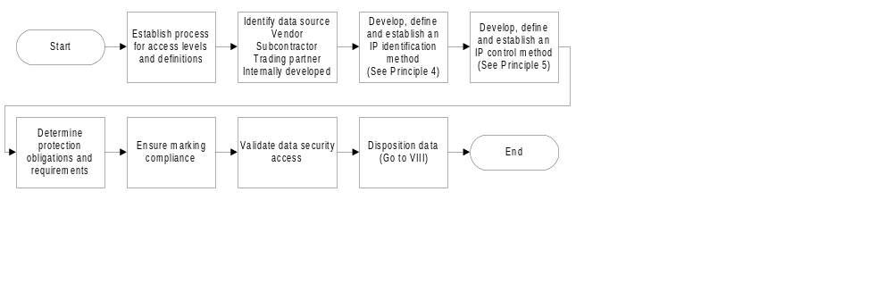The rights obtained from the provider through documented agreements, such as statements of work, license agreements and contract negotiations, determine how intellectual property is managed. The ability to deliver the information obtained from a supplier to a third party, as well as the obligations and requirements to limit access and use are also defined in these documents.
There are several varieties of proprietary data. Some examples include general business information (available to the general public), information to be used only within the organization (internal use only), information developed by the organization that has monetary value (company proprietary information), and organizationally developed information that has been officially registered with a legal authority (registered proprietary information). Data not specifically typed but that might be construed as providing an organizational advantage within industry is considered to be competition sensitive data. Examples include best practice information, proposal information and tools implementations.
Organizational policies for intellectual property management provide a standardized way to type, mark, identify, control and track ownership, rights to use and sell, access, distribution and disposition of IP within the organization. Management of intellectual property requires the following:
- Identify items that need to be protected and tracked.
- Store items in a protected environment or repository with limited access.
- Control access to and distribution of data dependent on data type.
- Provide security dependent on documented agreements and legal obligations.
In some instances there is a need to sell, purchase, or license intellectual property for purposes such as establishing standards, developing business relationships, creating new and larger markets, and realizing strategic goals. These transfers should take place under stipulated conditions and careful control to protect the data rights of the data originators and owners. Regardless of the type or source of intellectual property, manage it as an asset of the organization. Failure to successfully manage intellectual property can have, personal, organizational, national, and international implications.
The three enablers discussed below provide a basis for flexible and tailorable intellectual property management.

Enabler 6.1: Manage Data Access and Distribution
To effectively manage intellectual property, a method for managing data access and distribution needs to be in place. Access and distribution of data is critical to the protection of data rights. The process to support Enabler 6-1 is delineated in Figure 6-18 and defined in the sub-enablers
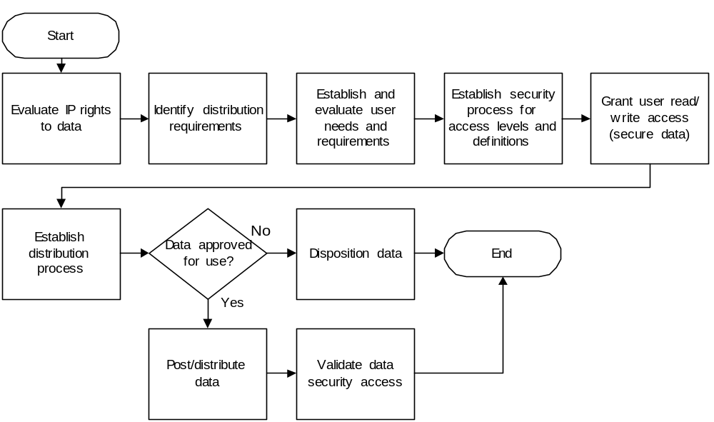
Figure 6-18 Process for managing data access to intellectual property, proprietary and competition sensitive data

Enabler 6.1-1: Establish and maintain a process for data access and distribution.
Review types and varieties of intellectual property that will be addressed, and create a method of controlling access and distribution. In a manual environment, intellectual property may be managed through limited access facilities such as locked files or areas. In an electronic environment, electronic methods such as organizational and role based access control are generally required to limit the electronic access of data.
Where organizational policies and procedures do not exist, document the access constraints for the various types and varieties of data. Once this process is defined, it can be applied at all levels of the organization to address all sources of data.

Enabler 6.1.1.1: Define access requirements.
Review documented agreements to verify that access rights granted support the intended use by the organization. If rights to data are not authorized, evaluate data to determine the currency of the business need within the organization. For those items no longer current, or where a need has expired, schedule disposition in accordance with the organization or department retention schedules and authorization for the intended use. Contract negotiations, subcontract negotiations, licensing agreements, royalty payments, and similar legal documentation define the rights to data. Data is not distributed or used until the legal right to do so has been verified.
Review contractual requirements and legal rights and responsibilities prior to providing access or distribution of data to trading partners, subcontractors, vendors and customers. If access is authorized through a documented agreement, verify the type of data needed by the user, as well as the distribution method and access level required to support the user’s needs.
When interchange data environments are required, define the levels of and definitions for access rights and establish the mechanism for authorizing that access.

Enabler 6.1.1.2: Ensure entitlement to access and use of data is validated and documented by the proper authority.
Ensure that the owner of the data (organization or individual representative) has authorized or validated the user’s need for access. Maintain records of access rights granted, distribution methods, and account authorizations for verification and validation purposes. Review these records regularly to ensure that data remains secure and access rights are current.
Before data is distributed, validate the information is approved or authorized for use. If not authorized, evaluate data to determine the reasons. Data is distributed or used only after authorization by a review authority. If authorized, distribute the data in accordance with the defined process and the user rights. This distribution may be performed manually, through email, by means of an electronic interchange data environment or any other method that meets the requirements of the process.
Validate the security of the data on a periodic basis as part of an audit activity. Failure to secure the data, or allow unauthorized use can result in monetary fines or other penalties for both organizations and individuals. Information to be considered for audit includes:
- IP is properly identified by type and catalogued
- IP is properly marked and tracked
- Patents exist where appropriate
- Copyrights are registered where appropriate
- IP rights granted are current and followed
- Import and Export evidence exists where appropriate
- IP user access rights are reviewed
- IP distribution is reviewed
- IP disposition schedules and methods are followed
As data or information is disposed of or considered of no ongoing value, it is handled in accordance with Principle 7.

Enabler 6.2. Establish and Maintain an Identification Process for Intellectual Property, Proprietary and Competition Sensitive Data
The process to support Enabler 6.2 is delineated in Figure 6-19 and defined in the text
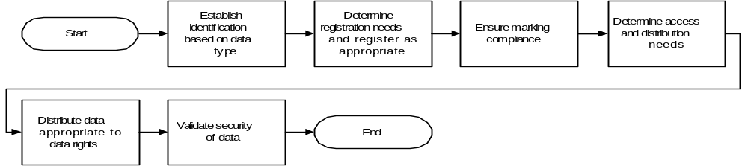
Figure 6-19 Process for identification, tracking and protecting intellectual property, proprietary and competition sensitive data

Enabler 6.2.1. Distinguish contractually deliverable data
At the organization level, policies are documented to define the process for distinguishing and managing intellectual property from other data. Prior to design of a product, whether organizationally or contractually funded, a process should be used to determine the data requirements for development of the product. When the product will contain information that is deliverable to a customer, an evaluation occurs regarding intellectual property and the legal responsibility to protect it, regardless of source. Negotiations occur with potential suppliers to establish an agreement to use or resell the data. The outcome of those negotiations is documented and forms the basis for what can legally be contracted to another party.
When a potential or contracted customer requests delivery of a product where legal rights to deliver to a third party do not exist, resolution must be reached with either the customer or the supplier, usually through negotiations. Even if data is not contractually deliverable, identify and secure it to protect the rights of the provider. Data is used in accordance with the rights granted by the provider, through contracts, subcontracts, license agreements, or other legal documentation. Always evaluate the obligations and legal responsibility for data protection.

Enabler 6.2.2. Establish and maintain identification methods
Organization processes should exist for identification methods that address data within the organization. Data and data requirements are defined and identified with unique identifiers, as delineated in Principle 4. At the project level, the identification methods should be documented if they deviate from an organizational policy or an organizational policy does not exist. This includes another layer of identification for intellectual property to ensure the data is handled in accordance with IP policies and legal obligations. Internally generated data can then be easily identified and typed for protection.
Evaluate internally developed and funded data to determine if a patent, trademark or copyright is feasible in the business environment. Register U.S. patents and trademarks with the United States Patent and Trademark Office (http://www.uspto.gov/ ). In the United States, copyrights are automatic. In some instances (e.g., protection of data rights in a global market) it is advantageous to register a copyright. Register copyrights with the United States Copyright Office (http://www.copyright.gov/).
Review data obtained from an external source to determine if it is registered intellectual property. Verify documented rights to data prior to use to ensure that appropriate protection of the data occurs.
An organizational policy or process for import and export control should address the legal obligations for importing and exporting data outside the country of origin. Review data prior to export to ensure compliance with organization processes and legal obligations. Obtain additional information and assistance for United States policies through the Bureau of Export Administration, U.S. Department of Commerce (http://www.bxa.doc.gov/bxahelp.htm).

Enabler 6.2.3. Establish and maintain tracking mechanisms for identification of data
Identification and control of data are addressed in Principles 4 and 5 respectively. There are however some additional elements of metadata that need to be tracked for intellectual property. Tracking mechanisms and evidence are fundamental for the following items:
- Distribution is appropriate to rights granted
- Appropriate maintenance of data is possible
- Configuration status of IP is maintained
- Import and export forms are maintained
- Licensed quantities and locations are tracked
- Appropriate rights are negotiated or granted for updated items
- Distribution (list of names, addresses, restrictions, etc.) is appropriate to rights granted

Enabler 6.2.4. Ensure compliance with marking conventions and requirements
Once intellectual property has been identified, it should be marked appropriate to its type or variety. When proprietary information or intellectual property is provided to the U.S. government, mark it using government notices or legends. See the glossary for definitions and marking references. Disclosure of proprietary information in any other context requires a nondisclosure agreement or other legally binding type of documented agreement. These legal agreements restrict the use and disclosure of the information being shared.
If the information is provided to a non-U.S. citizen, export control requirements need to be satisfied prior to disclosure. This includes printed, electronic or verbal disclosure of information.

Enabler 6.3. Establish and Maintain an Effective Data Control Process
The process to support Enabler 6.3 is delineated in Figure 6-4 and defined in the text of the sub-enablers.

Figure 6-20 Process for controlling, tracking, and protecting intellectual property, proprietary and competition sensitive data

Enabler 6.3.1. Establish and maintain control methods
Processes should exist for control methods that address data within the organization. Data is controlled so that changes to data are reviewed and authorized by the appropriate personnel and results are provided on a need to know basis. Details of the change process are defined in Principle 5. For intellectual property, control systems are different based on owners and use of data and include appropriate approval mechanisms and updated documented agreements for data rights. This provides another layer of control for intellectual property to ensure the data is handled in accordance with IP policies and legal obligations.
Evaluate internally developed and funded data to assess the impact of the change. Determine if a patent, trademark or copyright requires updating or re-registration as a result of changes. If re-registration is appropriate, register U.S. patents and trademarks with the United States Patent and Trademark Office (http://www.uspto.gov/ ). Register new copyrights with the United States Copyright Office (http://www.copyright.gov/).
Changes to the data may or may not impact documented agreements for data rights. Review documented agreements to assess the impact of the change. Areas of particular concern exist where the right to use the updated item is not part of the original agreement. In those instances, new agreements must be negotiated. Establish review and disposition methods for IP changes based on the business needs.

Enabler 6.3.2: Establish mechanisms for tracking and determining status of data
The mechanism for tracking intellectual property continues when tracking changes to IP. When changes occur, the ability to trace users of IP data assists in determining the distribution for approved updates. As with other IP issues, changes need to be tracked and the data rights reviewed before distribution.
At some point, rights to data expire or are no longer of value to the organization. If there is an organizational retention policy, or a legal obligation to maintain the data, retain the IP information, including the documented agreements that define the data rights. Principle 7 provides guidelines for data retention and storage.

Principle 7.
Retain Data Commensurate With Value
Introduction
The purpose of this principle is to delineate methods for ensuring adequate retention and preservation of data assets that are of value to the organization and effectively disposing of data assets that are no longer of value. Figure 7-21 illustrates the overall process.
Figure 7-21 Planning decision tree for data of sustained value
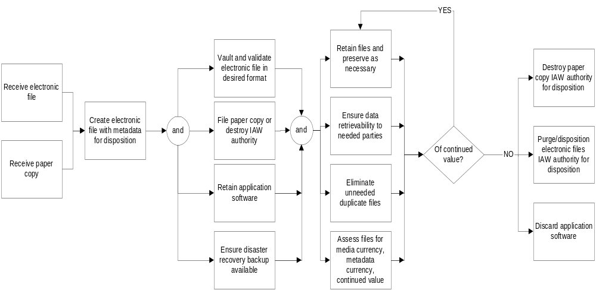
Any data assets that are of potential business, project, or operational value should be retained until their value is depleted. Data of sustained value to the organization should be retained and evaluated on an ongoing basis as notionally shown in Figure 7-21; an organization should have its own processes built upon this principle’s enablers and provide a basis for organizational behavior that ensures data is retained commensurate with its potential entrepreneurial, legal, and other work to the organization and the customer. The enablers described herein provide a basis for organization behavior that will ensure data is retained commensurate with its potential entrepreneurial, legal, contractual, and other worth to the organization and customer. Quality, accurate, and up-to-date data will aid in critical business decisions. Timeliness of the decision-making process with value added data will increase competitive advantage. The right data at the right time is cost effective and will reduce lead-time to decision making and business processes. Non-value added data should be removed from the organization’s inventory.

Enabler 7.1. Plan to ensure data is available when later needed
Data assets should, upon their creation and initial storage, have planned retention requirements identified and documented. Such business processes would cover archive formats, periodicity of review, purge planning, disposition funding, etc. Having clearly defined methods for retention facilitates retrieval. One such method is to develop an organizational policy on data retention. Considerations for such a policy are detailed in Enabler 7-2.
Effective control of data is best accomplished through defined process ownership and accountability. To ensure proper planning for eventual disposition of data assets, identify an appropriate data steward for planning disposition date(s) early in the data life cycle. These stewards should be trained in the organization’s retention processes and the disposal decision process. They manage physical custody of their assets to ensure, as a minimum, that electronic data with wide applicability is stored in a retrievable storage media; that inactive data is archived, that hard copies are protected, and that all are indexed for retrievability. They ensure that movement of data assets and their backups are known to them. Further, they ensure planning is in place to control data assets near the end of their useful lives such that the organization does not store items that no longer retain value.
Data stewards ensure that data is stored at authorized locations. Data asset backup copies should be maintained at a separate location from masters for best disaster recovery practice. Data asset backup copies should not be maintained or stored at unapproved locations, such as personal residences. The physical whereabouts of data assets are known and easily retrievable by those in need. Greater attention should be paid to ensuring backups of active data.
Maintaining control of the repository that indexes data stewards and the associated processes or data holdings they manage is also a data management function. This repository should be reviewed periodically to manage such things as:
- Change of stewardship driven by organizational charter changes, corporate mergers, or corporate divestitures.
- Change of stewardship driven by personnel changes - changes to position responsibilities, retirement, attrition
- Change of stewardship based on where data is managed during its life cycle - for example, from an on-site location in the early life cycle to an off-site location when data is archived
To ensure proper planning for storage in protected environments, investigate cost and facility availability to meet upcoming needs for data protection environments. Paper files may be somewhat protected from fire, for example, with inert gas systems. Protection of CDs and other heat and light sensitive items in warehouse environments may be ensured with effective cooling and humidity control. Protection of electronic files from viruses may be enhanced through an effective virus protection program.
An essential element of preservation planning is to ensure planning for adequate protection of data against potential disaster commensurate with the value of the data. Review risk areas where singular versions of data could be lost in the event of a disaster and develop plans to mitigate such risks. Mitigation may occur by developing duplicate copies or scanning paper documents to provide backup as well as maintaining electronic versions (tapes, CD, etc.) of files and associated software. Storage of the duplicated data at a separate locale or even region of the country is prudent to overcome risk of local disasters such as hurricane, tornado, or earthquake. Additionally, effective planning for disaster recovery in the event of a crisis, such as facility fire, server crash, flood, etc. mitigates the potential of data asset loss and implicit inability to retrieve such assets. For some organizations, a disaster has been cause to cease operations as no disaster planning was incorporated in the organization's basic business planning.

Enabler 7.2. Maintain data assets and an index of organization data assets
Data stewards are to ensure that accurate and complete records are identified, available for view by those with a valid business need, controlled, retained, protected, and subsequently disposed of in accordance with the requirements set forth for the data assets.
Setting of retention dates are the latest of dates set by law, by local policy, by ascertained potential need to the organization, or potential need to the customer. (Society of Aerospace Engineers Standard AS9034, “Process Standard for the Storage, Retrieval, and Use of Three Dimensional Type Design Data” provides related process descriptions and related information for aerospace-specific application.)
To ensure data assets are well identified, use appropriate identifying data pertinent to the items – metadata - to enable its retrievability. Such metadata may include date, contract number, author, title, general topic key words, owning organization document number, document serialization, default retention date and data steward, etc. Effectively identified data assets enable timely retrieval and destruction as appropriate.
To protect data assets from unauthorized viewing, place security requirements on data assets as appropriate (Principle 6). Organization data assets may be of a proprietary, Government classified or other sensitive nature that warrant protection against unauthorized viewing. In a paper environment, protection may be ensured through physical security. In an electronic environment, protection may be ensured through segregation of data by server, by firewall, by password, etc.
When evaluating how to store data, some questions that may be asked may assist in decision making:
- Will the data ever be used as direct source information in the creation of new material.
- How long will this electronic data likely have value to the organization? If a long duration, electronic data migration might be considered more heavily than if a short duration.
- How long will this paper data likely have value to the organization and how frequently might it be accessed? If a long duration, electronic conversion may be warranted
- How hard it is to retain old equipment and software for retrievability and readability of the files over their anticipated life?
To ensure data assets are readable in future years, storage of data in neutral formats is preferable if the data is not anticipated to be manipulated later or used in the creation of new material. Neutral formats work well for data that is only for reference and not a source for future work.
To ensure any data assets are readable in native formats for later manipulation, retain necessary computer resources to recall and install, view, revise, print images or refresh to newer technology. Alternatively, plan to periodically migrate data assets to current software applications and hardware formats for continued currency and availability for retrieval. The decision process to retain obsolete computer resources or to refresh to newer technology is a business case, driven by economics pertinent to the predicted likelihood of data reuse. In the case of retaining obsolete resources, this process may involve extending date expiration-sensitive licenses or arranging software support into out-years. By so retaining computer resources, the organization ensures pertinent records are viewable and editable upon later need. In the case of migrating data assets to current formats, periodic migration to current software with its correlated validation for accuracy occurs. Failure to continue migration to current formats can be costly to the organization. It is time consuming and often expensive to locate a vendor or organization with the capability to migrate to current technology media.
Hard copy data, while not as susceptible to many issues electronic media face, have their own vulnerabilities. Many inks fade over time, degrading legibility of data on Mylar. Copied material is somewhat subjected to its ink lifting, particularly if exposed to heat.
To mitigate opportunity of electronic data loss are not erased or lost due to shelf-life limitations of storage media over time, perform periodic refreshes and data validating as necessary to ensure data assets are refreshed. Consider migration to state-of-the-art software formats and storage media. Some CDs, whose shelf life has been viewed as very long term, are now rendered useless because of the acid content in the inks used to print labels. Inventories of data assets maintained in current software formats allow for fast retrievability and easy readability. Maintaining a data refresh schedule will facilitate having electronic data receive the proper attention before media shelf lives are exhausted.
Table 7-12 Representative Refresh/Migration Intervals
MEDIA | REFRESH/MIGRATION | ANTICIPATED LIFE
File server | Backup daily | 5 years
Disks, compact (CDs and their variations) | 5 (10) years | 25- 100 years
Disk (Diskette), 8-inch | Migrate to current formats | 1-3 years
Disk (Diskette), 5 ¼-inch | Migrate to current formats | 1-3 years
Disk (Diskette), 3 ½-inch | Migrate to current formats | 1-3 years
Tape, cassette (magnetic tape, cartridge) | Migrate to current formats | 10-30 years
Tape, magnetic (magnetic tape, reel) | Every 5 years migrate to current formats | 10-30 years
Magnetic tape, compact | Every 5 years migrate to current formats | 10-30 years
Removable disk, ZIP/JAZ | Every 5 year, migrate to current formats | 5-15 years
Microfilm/microfiche | Consider for migration | 40 years
PC hard drives | Back up to other locations | 5 years
This data is gathered from experiential as well as vendor sources. It is for general information only.
To minimize retention of duplicate media, review duplicate data assets for need to store multiple media beyond that needed for disaster recovery. When records exist in more than one physical medium without specific need, unnecessary duplication wastes physical space (in a paper environment) and digital storage (in an electronic environment). On the other hand, an organization need to be cognizant of business needs or specific legal and contractual requirements that may mandate that multiple media be retained.
Providing special protection and backup for vital data records provide greater likelihood of retrieval for items of key legal or strategic significance (Principle 6). Such protection may include greater physical protection such as a rodent-proof container, fireproof vault, temperature/humidity controlled area, etc. It can also mean added security (access restriction) protection. Data with greatest potential loss to the organization may be candidates for given special attention. Added measures to prevent data getting to the possession of unauthorized personnel needs to be carefully weighed against the inherent advantages to ensuring broad availability of important data. In an acquisition and merger environment, proper attention to the rights of the current and prior data owners is paramount to doing business. Special requirements may exist for retention and/or disposition relative to previous or new corporate ownership. For example, data pertaining to a certain project, with certain tax application, created during a certain period, etc. may have to be reviewed by another organization as part of the disposal process.

Enabler 7.3. Assess the current and potential future value of the organizations’ data holdings
Data is periodically assessed such that the organization does not retain non-value added data. As a minimum, data should be re-evaluated at the time originally designated for disposition, its original default retention date. Re-evaluation considers the latest of dates set by law, by local policy, or by ascertained potential need to the organization or potential need to the customer.
Organizations need to periodically reassess the value of current holdings to the organization's future. Reevaluation occurs easily at some key points in time for example: planning for a physical move; upon transition from one contract to another; upon reassignment of data stewards, or upon corporate reorganization or sale.
The periodicity for review of holdings can be easily managed in an electronic environment. Many organizations have computer reporting of potentially obsolete data by virtue of a metadata sort, for example, date-driven reports that flag original metadata entries as suggesting they are obsolete. At such time, the organization reevaluates the continued value of such data. Upon reevaluation, default retention dates may be readjusted or, if the data is deemed non-value added, data processes for disposal may be engaged. When evaluating current/future value of data, some questions that may be asked:
- What data is currently stored and for what purpose?
2. Is the data accurate and up-to-date?
- What are the criteria for the storage life of data?
- What are the costs associated with data retention?
- Will retaining the data enhance network security?
- Is there potential for this data to satisfy legal requirements?
All assessments of value and disposition processes pertinent to particular data should cease immediately upon knowledge of a potential or initiated lawsuit and not be re-initiated until after such action is completed.
Active data are those items that need to be available to the organization for regular reference and need to be readily available. Inactive data is data that still retains value but is not considered to have regular, continuing need. Such data needs to be retrievable, but can be stored less centrally. The data retention program should include a periodic review to determine when data is no longer being actively use and procedures to move the data into an archival location invoked. Both active and inactive data needs to be reviewed periodically for deletion.
Inactive data frequently relocated to an archival database, if electronic, or an off-site location, if electronic or paper. Relocation of such inactive data frees up physical and/or digital storage space. Vendor off-site storage may be particularly attractive for storing historical hard copy that is space consumptive. Many vendors store data at rates that allow cost-effective retention. If these archived files have a backup version or second copy available, storage of the duplicated data at a separate locale or even region of the country is prudent to overcome risk of local disasters such as hurricane, tornado, or earthquake. Conversely, if these archived files have no backup version or second copy, they are likely of greatest value to the enterprise with local storage for fast ease of retrieval.

Enabler 7.4. Disposition data
Upon determination that data retained is not of continued value, processes are engaged to dispose of such data.
An organization should discontinue use of personnel energy and physical space and/or digital storage dedication to non-value added data. Accordingly, such non-value data should be purged from the organizational records and disposed of in a manner that makes best business sense. When data is removed, its associated metadata should likewise be removed. A record should be retained to identify what documents were destroyed, when they were destroyed, and who authorized the destruction. An organization needs to have an effective process that ensures qualified individuals or teams of potentially interested parties authorize destruction. In some cases, as in merger environments, other organizations may be required to jointly authorize destruction.
The organization should ensure data assets that may be of interest to other parties are prevented from wide or public availability upon destruction. If there is potential value to entities outside the organization, such measures as electronic deletion, shredding or burning may be appropriate methods for destruction. Effective destruction processes ensure that non-value data to the organization - its trash - is not compromised, becoming another organization's treasure.
Failure to dispose of data in a timely, appropriate manner may cost in poor use of space (square footage expenditure) or compromise of data.
Data that has value is worth retaining and should be done in a managed way with effective backup in case of disaster recovery. Data that is not managed or indexed is frequently irretrievable should a need for it arise. Organizations spend millions in litigation alone that can be traced to failure to retain valuable data. Organizations spend millions on redesigning information that resides elsewhere. Organizations spend millions on duplicate endeavors. Conversely, organizations spend millions in lost space by storing data that is non-value added.

Principle 8:
Continuously Improve Data Management
Introduction
In a rapidly changing technological society, it is crucial to continuously improve the quality of the resources that house one of an organization’s most valuable assets, data. Metrics are essential for determining where to improve and monitoring improvement. They should be designed to positively motivate, rather than keep score, and should focus on future strategy, not simply a compilation of past history. The purpose of this principle is to provide a basis for implementing a process for quality improvement. Figure 8-22 illustrates a methodology.
Figure 8-22. Improving Data Management
Establish and maintain metric process and reporting
Monitor data quality
Improve data management
Establish tools & infrastructure to be used to support the process

Enabler 8.1 – Recognize the Need to Continuously Improve the Quality of Data
Data management is the function responsible for ensuring that the quality of data is consistent with the users’ requirements. The organization should identify the users most directly involved with metrics and performance measurements and they should be full members of the data management team. This may include personnel familiar with administrative, financial, technical and, where applicable, contracting issues. In order to effectively facilitate continuous improvement, the following questions need to be considered:
What type of data is required, by whom and when
- Who will use the data
- How will the data be used
- What is the user’s infrastructure
- How will the data be delivered
- Where is the data maintained
The answers to these questions establish a meaningful process and should be considered not only for the specific project but also reviewed for the overall impact to the organization. Careful planning for the type of data and who will use it will not be successful if the organizational infrastructure does not permit processing or delivery.

Enabler 8.2. Establish and Maintain a Metric Process and Reporting Strategy
The steps in Figure 8-23 assist in establishing a reporting process that identifies and utilizes appropriate, advantageous metrics to improve the quality of data an the process that reports the quality. A consistent and repeatable process based on this enabler permits proactive actions by the organization and specific projects.
Figure 8-23. Process and Reporting Strategy
Establish reporting strategy
Identify metrics

Establish reporting process
Analyze the Reported Data

Improved business processes
Identify improvements
Implement proactive solutions

Metrics vary from organization to organization and from project to project. These process measurements should be simple and accurate indicators of performance, yet provide sufficient data to allow analysis. Examples of metrics that may be useful to assess the volume and performance of data activity are shown in Table 8-13.
Table 8-13 Examples of Data Management Metrics
Metric Name | Definition | Suggested Reporting Frequency
Data Schedule Status | Summarizes delivery status, contains number delivered early, on-time and late by month | Monthly
Electronic Delivery Status | Summarizes progress towards electronic delivery; contains the percentage of deliverables made electronically for each month | Monthly
Project Data Report | Summarizes the project data traffic; identifies the number of correspondence items transmitted between prime trading partners each month. | Monthly
Data Acceptance Rate | Percentage of submittals approved and disapproved by customer on first submission | Monthly
Review Cycle Time | Measures the cycle time of the review and approval process both internally and externally | Monthly  Issues addressed more frequently
Problem Reports | Measures the number of problems reported and time to problem closure. | Monthly
Customer Satisfaction | Measures customer satisfaction trends using survey methodology | Annual or on Project Closeout
For example, analyzing the review and approval process may identify areas for potential cycle time reduction resulting in improved data deliveries and schedule performance If a particular area is revealed to have a longer turnaround for approval, the causes can be examined and corrected or the process can be changed to accommodate needs and achieve objectives. Publication of results and findings provides a method to standardize metrics across the organization.

Enabler 8.3. Monitor the Quality of Data to Improve Data and Processes
Monitoring the data quality (Figure 8-24) through the use of metrics ensures that changes in initial input quality are identified. Degradation of the data below the metric goal identifies a need to re-evaluate the goal ad possibly update the process. As quality improves, the process can be changed to accommodate more stringent goals. The value of this activity is the on-going assurance that the quality of the data meets or exceeds requirements through an up-to-date identifiable process that also contributes to achieving organization goals.
Figure 8-24. Monitoring Data Quality
Monitor data quality
Establish input plan
Maintain identifiable process
Encourage Process Improvements

Develop and implement a process improvement plan, with resources planned and allocated, to improve process performance and capability. Update the plan at defined intervals or as required. The plan should include identification, evaluation and incorporation of new technology innovations into the defined process. The plan should also include measures of effectiveness from which metrics can be derived.

Enabler 8.3-1. Implement a Strategy for On-Going Improvement
The purpose of implementing a strategy (Figure 8-25) for on-going improvement is to ensure the plan is current and continues to provide direction and meet requirements. The value gained from this plan is the ability to readily identify improvements toward an objective of continuous improvement and preventative maintenance.
Figure 8-25. Improvement Strategy
Incorporate
New technology
Identification of
data measurements
Evaluate and
Monitor data
Update plan
As required

After establishing baseline requirements, a continuous improvement plan should be implemented. A systematic assessment of the process should be applied through planning, measurement, causal analysis and defect prevention, execution and process refinement. The results provide the basis for modification of systems and personnel retraining, as required. Adherence to this plan ensures that goals are reviewed on a consistent basis and adjusted as improvements in quality are made.

Enabler 8.4. Improve Data Management Through a Systematic and Self-Diagnostic Process
The four steps listed in Figure 8-26 are necessary in the development of a systematic approach to self-analyzing the identified improvement process. This self-assessment will result in the ability to identify, analyze, address and correct data issues. The end result will be ready access to pertinent and accurate data.
Figure 8-26. Self-Diagnostic Process
Develop self-assessment process
Identify objective evidence of improvement
Validate improvements
Identify area in need of improvement

There are numerous process improvement projects used by organizations today. Any systematic process used should address/identify the following:
- Prevent errors from recurring by identifying and eliminating the cause
- Periodic reviews, audits and publication of metric results
- Lessons learned, documented and published for reuse
- Identification of best practices, documented and published for reuse
For maximum gain and return on the costs of development, an effective process improvement process, will include periodic reviews and audits to ensure on-going adherence to the process. Lessons learned will be shared with others to assist in preventing the same errors on other projects within the organization. From this sharing exercise, best practices will be identified and shared within and outside the organization.

Enabler 8.4.1. Identify Objective Evidence of Improvements
Develop objective evidence of improvements to provide concrete indication of the process results and/or actions and how they correlate to the process improvement (Figure 8-27). Validated documentation will ensure that documented proof of improvements achieved as a result of the process improvement is readily available.
Figure 8-27. Develop Objective Evidence of Improvement
Measure process results
Analyze and match results to process
Document validated results
Identify process criteria to measure

Creation of a process assessment matrix, or other tracking method, listing the stated criteria, would be advantageous in indicating the process/steps taken to accomplish the results of objective evidence. Efforts expended and lessons learned to improve the process should be documented to leverage the efficiency of future measurements.

Enabler 8.5. Establish the Necessary Tools and Infrastructure to Support the Process and Assess the Results
Establishing the necessary tools and infrastructure (Figure 8-28) is essential. Identifying the data requirements at project inception and the mechanisms on which the process will be based will reduce confusion and increase productivity. Knowing the expectations in the beginning will benefit the project and the organization by allowing time for planning and achievement of the expected results thus saving time and money.
Figure 8-28. Tools and Infrastructure Support the Process and Assess Results
Identify tools to support process and function
Plan for expected results
Monitor performance and results
Identify data requirements and mechanisms

Tools may vary depending on the requirements and available infrastructure. At a minimum, the tools should have the capability to support the organizational process and perform the following functions:
- Data scheduling
- Action tracking
- Data delivery
The process infrastructure at a minimum should include:
- Resources
- Information systems dependencies
- Training approach
- Other essential elements needed to support process improvement
Metrics enable:
- Performance monitoring
- Progress demonstration
- Project completion
The establishment of a process to monitor data performance and progress benefits everyone involved. The process should consider each of the steps involved in data management and allow for improvement based on identified process changes. Metrics should be of value and show a relationship to the process improvement – not just measure. The types of data, its use, access and storage along with infrastructure need to be considered in the development of the process.
The physical evidence that metrics are available provides a level of confidence in the process being measured. A properly established set of metrics supports goals and process improvement, in addition to providing a basis for assessing the improvements and assessing trends.

Principle 9
Effectively Integrate Data Management and Knowledge Management
Introduction
This principle describes the interdependent relationship between data management (DM) and knowledge management (KM). Since knowledge management and data management are naturally interdependent, the objective of this principle is to distinguish the roles of each so that, in practice, KM and DM efforts are complementary. Ultimately, if DM and KM are managed such that they are complementary, the organization and its trading partners will achieve increased return on their intellectual assets investment. Figure 9-29 is a top-level process view.
Figure 9-29. Understanding the Interdependence of DM and KM
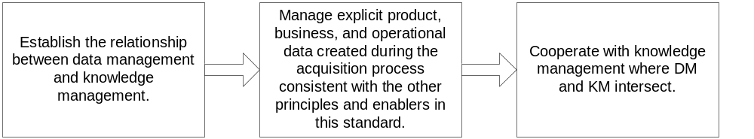

Enabler 9.1. Establish the relationship between data management and knowledge management
Table 9-14 illustrates the relationship between data and knowledge. The scope of knowledge spans both explicit information (data that is recorded on media) and tacit information (information that is held in the minds of individuals). Explicit data includes both structured data, such as is found in traditional databases, and unstructured data, such as is found in technical manuals, drawings, and reports. The term “unstructured” is used in the information technology field to contrast with the structured data found in databases. Unstructured data often does have some structure, such as a table of contents.
Table 9-14 Relationship Between Data and Knowledge
Type | Explicit |  | Tacit
Type | Structured | Unstructured | Tacit
Type | Transactions | Collaboration
Examples | Purchase order  Purchase order acknowledgement  Invoice  Remittance advice  Request for quote  Shipping schedule | Technical report, Analysis report, Specification, Manual  Parts list  Drawing  … | Mental models  Informal recipes  Rules of thumb  Lessons learned  Communities of practice  …
Normally responsibility of | Database administration | Data management | Knowledge management
The key insights regarding knowledge management, are:
- Knowledge comprises both explicit and tacit information
- Data can be structured or unstructured
- Structured data, which supports transactions, has historically been the domain of database administration
- Unstructured data, which supports collaboration, generated as part of the acquisition process has historically been the domain of data management. There is much other unstructured data well outside the scope of historical data management. Examples are the books and articles that are managed by librarians; human resource files managed by that function, etc.
- Knowledge management, as it is emerging contemporaneous with the development of this data management standard, extends to the management of human aspects of knowledge such as the fostering and support of communities of practice.
Knowledge management as a named field is relatively new, dating to approximately the mid-1990s. Thus the KM field is still emergent. Data administration and data management date back at least 40 years and have historically been separate fields. In past years, data management, historically, dealt mostly with paper products that described the product of an acquisition process. Data administration dealt mostly with automated data. With the automation data these two fields are migrating closer together. As a minimum, data management practitioners need to possess effective electronic skills to host and to search for data electronically, and to provide guidance on repository management, to have electronic user skills.
As was discussed in the introduction to the standard, data can be defined in terms of broad classes (product, business, and operational). The scope of data management, within the context of this DM standard, extends primarily to product, business, and operational data as created and maintained during the life-cycle process. Since data management provides a solution for management of explicit product, business, and operational data created during the acquisition process, it inherently provides that part of the solution for knowledge management.

Enabler 9.2. Cooperate with knowledge management where DM and KM intersect as KM Methods Develop
The emerging field of knowledge management is developing methods for managing tacit data and the human aspects of knowledge. All of these methods are subject to rapid change as enabling technologies emerge and mature. Since tacit data and the human aspects of knowledge management are outside the domain of data management as defined in Enabler 9-1, the best strategy for data management is to cooperate with knowledge management as KM methods develop while avoiding duplication or conflicting with those methods. KM implementations generally stress three elements:
- Organizing content (repositories and structure)
- Connecting people (for purposes of facilitating data exchange)
- Managing change (promoting knowledge sharing behavior and provide tools that facilitate knowledge management within the organization and with its trading partners.)
For any organization, DM and KM will intersect with regard to element 1 and potentially element three (with respect to tools). Because the state of KM is fluid, the methods in use are organizationally dependent. Therefore integration with regard to element 1 and element 3 requires understanding the state of KM capability in the organization with respect to these elements.

Enabler 9.2.1. Understand state of KM in the organization
There are three steps required to understand the state of KM in the organization.
1. Determine through interviews or similar means if the organization has “stood up” either a formal or informal knowledge management individual or group. If there is no such individual or group then KM activity is ad hoc at best.
2. Determine through interviews or similar means if the organization has accomplished a KM capability self-assessment that is an internal assessment of its KM capability.
3.a. If the organization has accomplished such a self-assessment and it is reasonably current, or if one is intended within a reasonable time period, use the results of that self-assessment.
3.b. If there is no such self-assessment accomplished or planned, then it will be necessary to assess the value of developing a self-assessment, considering such elements as corporate culture and vision as well as cost. Such an assessment subsumes broadening the role of DM to encompass KM. Such assessments may yield tremendous potential benefit if a project is in the early phases of the life cycle. While inherently of less value in the later phases of the project’s life cycle, projects with long anticipated future use may still warrant a more encompassing DM role.
3.c. If the assessment suggests merit to further pursuit, then perform a self-assessment.

Enabler 9.2.2. Coordinate DM and KM efforts.
Based on the results of enabler 9.2.1, coordinate DM and KM efforts for elements 1 and 3. The specifics will depend on both the results of the KM self-assessment and the state of DM in the organization.

Application Notes
- EIA 859 is a principles-based guidance document. It is not intended to be a compliance document in a contract for purchase and acquisition of a product. It may be used as a source for relevant information when preparing such items as a request for proposal or other business contract agreements. Following EIA 859 principles will enable users to establish, plan, document, and communicate appropriate and consistent Data Management programs and plans for an enterprise or project environment.
- Data Management practices should be selected and applied in a context and to the extent appropriate as they are used in the product development or data-managed environment. The chosen practices should fulfill the scope, shape, and extent of the Data Management solution that best addresses and fulfills objectives.
- This standard should be used to design, plan, implement, and sustain effective Data Management solutions for the enterprise or the project. Because this is a principles-based standard, this material can be used to communicate and convey effective DM solutions and processes. Example users might be:
  - an auditor or evaluator who is writing criteria for measurement of a process;
  - an evaluator who is seeking best methods for Data Management and associated solutions;
  - an author who is drafting a DM plan.
- This standard provides the basic principles and terminology for data management, and has been integrated with EIA-836 and ANSI/EIA-649A to ensure standard use of terms and definitions.
Annex A Data management principles and related enablers

Annex B Flowcharts

Annex C Application Templates
Annex D Related Documents
Annex E Glossary

Annex F Overview Of Data Management Tasks And Subtasks As Defined In The Present Standard, As Well As Related Skills

Annex G Acknowledgement of Participants in EIA Standard 859

